Year 6 | Autumn 1 | Autumn 2 | Spring 1 | Spring 2 | Summer 1 |  | Summer 2
Theme | Living things | Christmas | Wonder |  | Mayans/ Anglo Saxons |  | Transition
Core Text | The Spider and the Fly by Mary Howitt  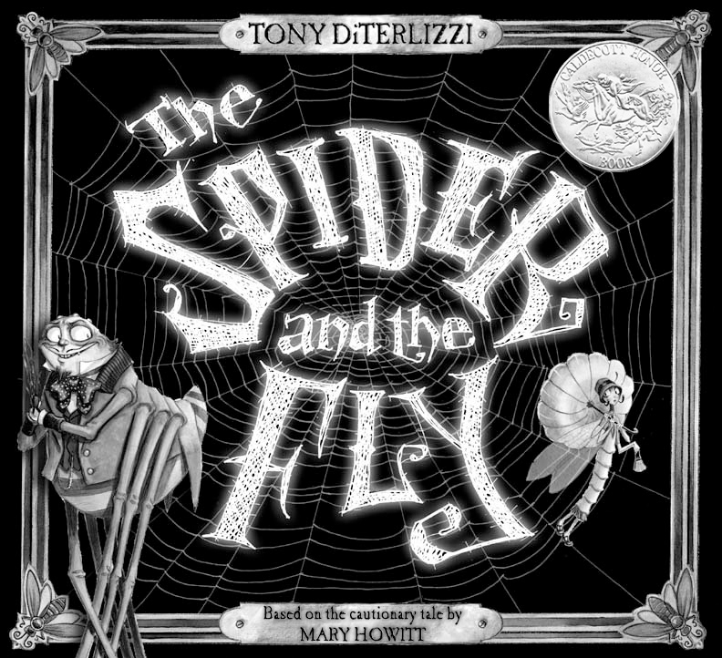  Relationships | A Christmas Carol by Charles Dickens  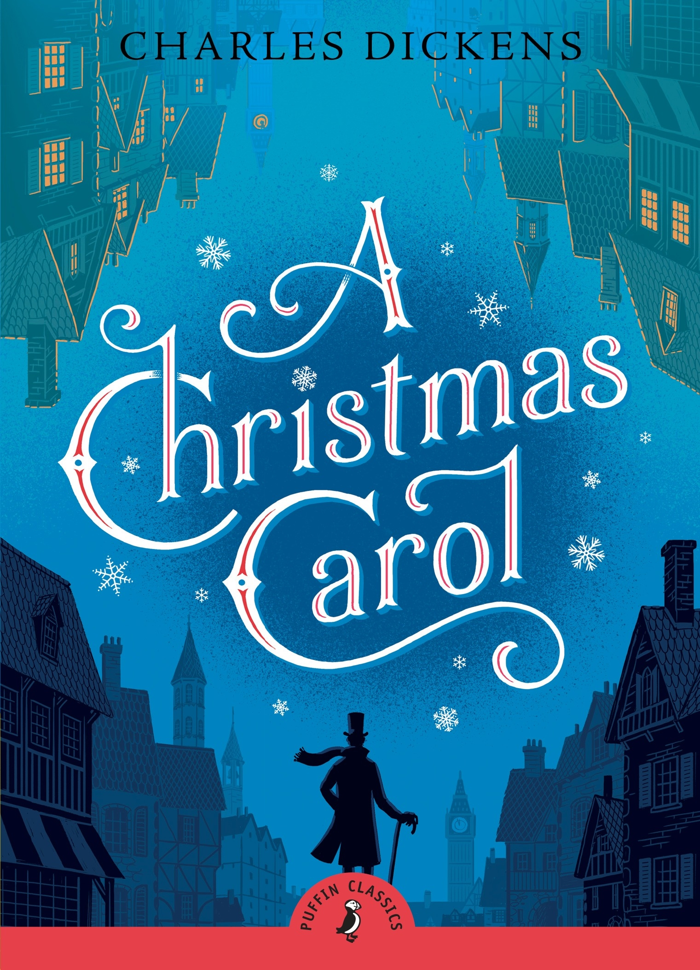  Mental health and wellbeing | Wonder by R J Palacio  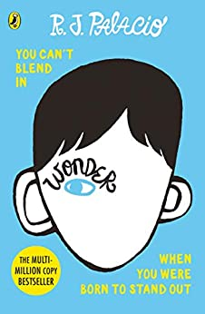  Relationships  Citizenship | How to live forever by Colin Thompson  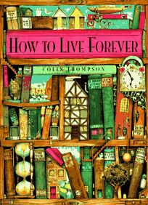 | SAT’s Revision  Video shorts –  Road’s End, Alma  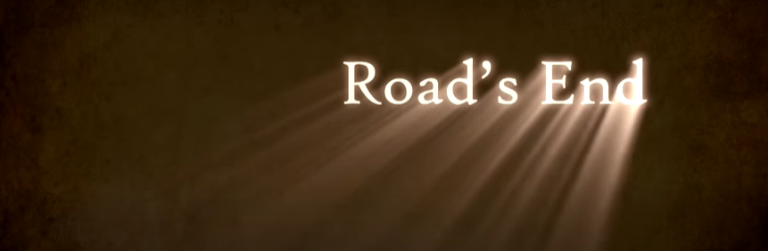  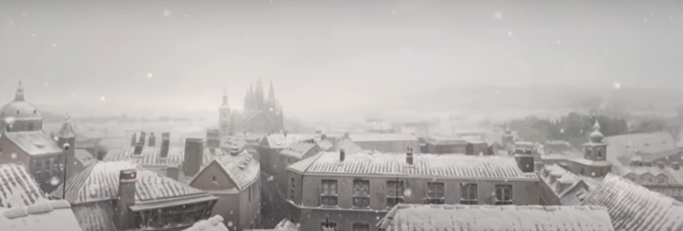 |  | Macbeth  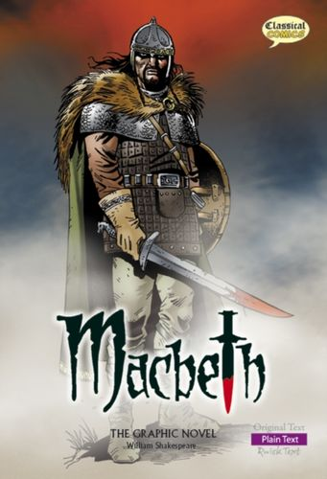  Mental health and wellbeing
Writing Outcomes | Persuasive letter to warn the fly  Balanced argument to show both sides of an argument: Whose fault was the death of the fly? | Character description of Scrooge.  Write a narrative to create tension. | Informal Diary showing Auggie’s thoughts and feelings.  Formal letter responding to points made. | Setting description of an unusual library.  Peter’s adventure portal story | Narrative – suspense stories |  | Persuasive Letter  Internal monologues/ soliloquys
Class book | The Last Bear by Hannah Gold  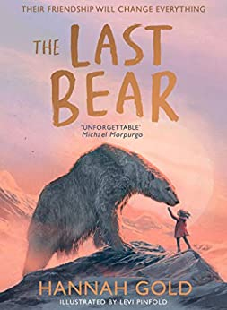 | Christmas in the trenches by John McCutcheon  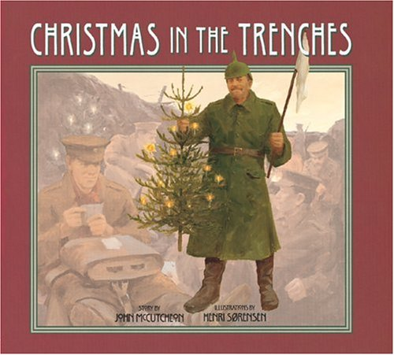 |  | The Night Bus Hero by Onjali Q Raúf  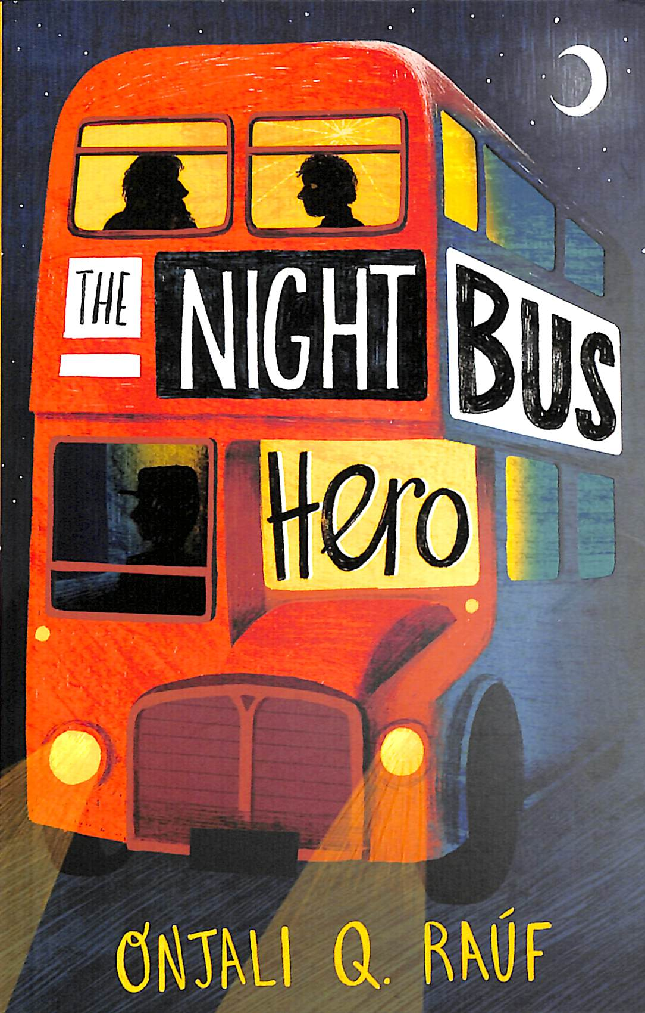 | The Hero Twins: Against the Lords of Death (A Mayan Myth) by Dan Jolley Graphic novels)  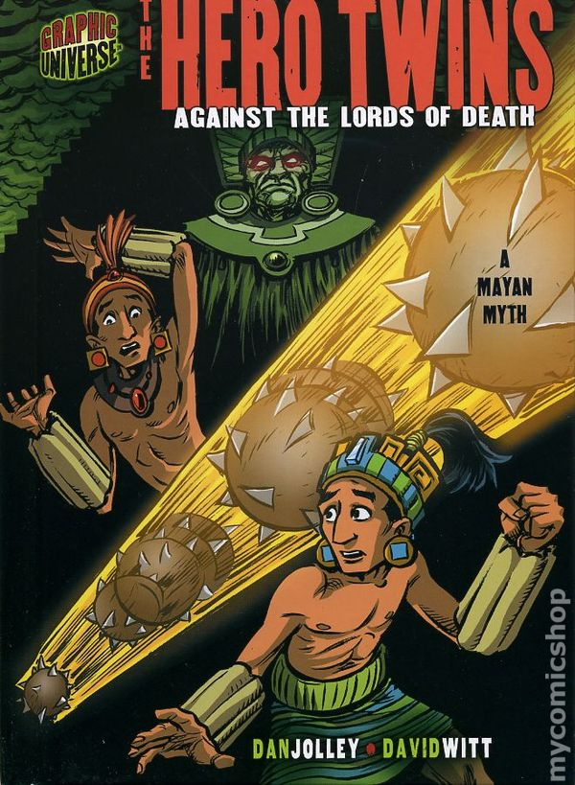 |  | Kensuke’s Kingdom by Michael Morpurgo  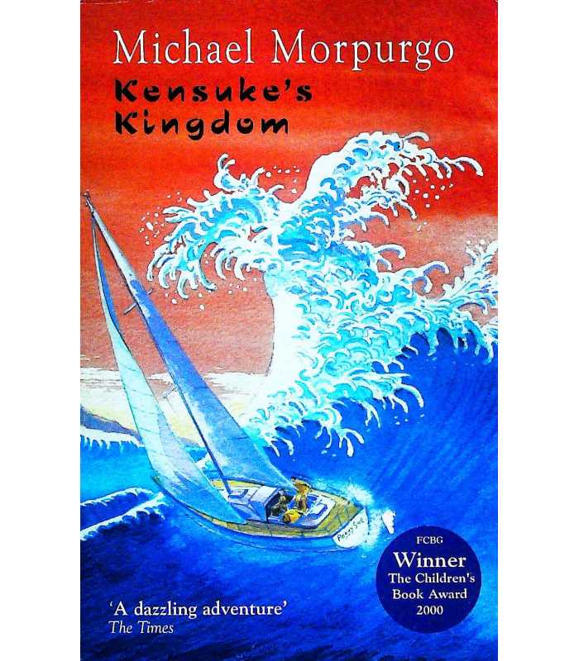
Reading (Ready Steady Read Together) | The Wolves of Willoughby Chase  Black Beauty  Woman In Science  Survivors  The Final Year  Overheard in a Tower Block | The Island at the End of Everything The House with Chicken Legs  The Diary of a Young Girl The Place for Me  Digging for Victory Poems from the Second World War | Saffiyah’s War When the Sky Falls. Can You See Me? The Story of Science On The Move New and Collected Poems for Children | Refugee  Darwin’s Dragons  Follow Your Dreams  Rise  My Heart was a Tree  Stars with Flaming Tails | Grimm’s Fairy Tales The Boy in the Tower Can You Get Rainbows in Space?  Cheeky Treats  A Child’s Garden of Verses  Out There in the Wild |  | Orphans of the Tide Asha and the Spirit Bird  Marcus Rashford You Can Do It  100 Books to Check Out Before You’re 12  A Poem for Every Summer Day Everyone Sang
Maths | Unit 1: Place value within 10,000,000 (7 lessons)  Unit 2: Four operations (I) (10 lessons)  Unit 3: Four operations (2) (9 lessons) | Unit 4: Fractions (1) (11 lessons)  Unit 5: Fractions (2) (9 lessons) | Unit 7: Ratio and proportion (9 lessons  Unit 8: Algebra (11 lessons)  Unit 9: Decimals (9 lessons) | Unit 6: Measure – imperial and metric measures (5 lessons)  Unit 10: Percentages (9 lessons) | Unit 14: Geometry – position and direction (4 lessons)  Unit 13: Geometry – properties of shapes (12 lessons) |  | Unit 11: Measure – perimeter, area and volume (11 lessons)  Unit 15: Problem Solving (14 lessons)  Unit 12: Statistics (10 lessons)
Science | Science – Living Things and their habitats/ classification  Science-evolution and inheritance Into University | Science-electricity | Science – Living Things and their habitats/ classification | Science - Human body  Science week | Science - Human body |  | Science – Light
Computing | Computing systems and Networks – Communication and Collaboration | Creating Media – Web Page | Programming A – Variables in Games  Safer Internet Day  Online Safety | Data and Information – Introduction to spreadsheets | Creating Media – 3D Modelling |  | Programming B – Sensing Movement
Art |  | How can I create a photomontage using my imagination? Imagination – collage: Hannah Hoch |  | Who was Frida Kahlo and what inspired her artwork? How can I incorporate her style in my own work? Portraits/ Sculpture: Frida Kahlo |  |  | How will I remember my time at Radford Academy?  Still Life/ Printing: Paul Cezanne
D&T | How can I make a functional automata toy to meet my design brief? Mechanisms (Cams) |  | How can I develop a steady hand game for the Summer Fair? Electronics (Steady Hand Game) |  | Could you be a Maya MasterChef? Food (Maya MasterChef)
History | Martin Luther King - Who was Martin Luther King Jr and why is his legacy so important?  Citizenship |  |  |  | Who were the Mayans and Anglo Saxons and why are they important?  History – Mayans/ Anglo Saxons
Geography |  |  | Geography – The United Kingdom |  |  |  | Geography – local area
Music | Clarinets/ Guitars
RE | Islam – What is the best way for a Muslim to show commitment to God? | Christianity – Do Christmas celebrations and traditions help Christians understand who Jesus was and why he was born? | Christianity - Beliefs and Meaning - Is anything ever eternal? | Christianity – Easter - Is Christianity still a strong religion 2000 years after Jesus was on Earth? | Islam - Beliefs and Moral Values - Does belief in Akhirah (life after death) help Muslims lead good lives?
PE | Drumba  OAA | Swimming | Gymnastics  Yoga | Invasion Games  Yoga | Real PE – Dance  Athletics | Drumba  Striking and Fielding
Spanish | Mi Casa (My house) | En el colegio (At school) | Yo en el mundo (Me in the world) | Tradiciones y celebraciones (Traditions and celebrations) | Mi fin de semana (My weekend) | Comer Sano (Eat Healthy)
RSHE | Safety Zone- Keeping safe (H15) (2 lessons)  Introduction: Setting ground rules for RSE & PSHE lessons (1 lesson)  Identity (2 lessons)  Mental health and wellbeing | Economic Wellbeing (5 lessons)  Economic Wellbeing | Citizenship – Twinkl Santander lessons (4-6)  Economic Wellbeing  Into University – Goals and Aspirations (H5)  Relationships  Online Safety | Pintsize theatre – Dorothy’ Homelessness, crime and anti-social behaviour  Mental health and wellbeing  Road Safety – (H21)  Knife crime/ County lines workshops | Health and Well-being (science) (H1-3/ H16-17)  Mental health and wellbeing  Keeping Safe - Residential (H9-11)  Relationships  Citizenship |  | Transition Lesson (H8)  Family and Relationships (Great Project) (R1-21)  Relationships  Online Safety  Safety and the changing body (H18-20)  Relationships
My Happy Mind | Meet Your Brain (3)  My Happy Mind Places (2) | Shared Responsibilities (2)  Showing Respect and Managing Hurtful Behaviour (1)  Celebrate (2)  Communities (1) | Appreciate (2)  First Aid (1)  Drugs, Alcohol & Tobacco (1)  Media Literacy & Digital Resilience (2) | Relate (2)  Friendships (1)  Safe Relationships (1) | Engage (2)  Be Your Best (3) |  | Transition Programme (4)  RSE
LTE | Last Stop  Citizenship | Voices in the Park  Relationships | Maker | Knight | Feathers |  | I (a)/ Survivor/ Home/  Who/ Island
Oracy outcomes | Head boy / Head girl speeches  Perform Spider and the Fly poem | A Christmas Carol performance | Science Fair presentation – prepare | Debate – Should we live forever? | Class presentation – non-chronological reports (History museum?) |  | Leavers’ Assembly
Enrichment | -Safety Zone (12th September)  Bikeability  Into University  Windmill Gardens | A Christmas Carol Performance  A Christmas at Newstead trip  Church visit – Christingle  Christmas Carol Production | D&T. Electronic Games for school fair  Safety Internet Day | Human Body Science Fair.  Church visit | MasterChef challenge  Sponsored Walk  London Residential  Islamic Centre visit |  | Great Project  Into University transition workshop

