Year 5 | Autumn 1 | Autumn 2 | Spring 1 | Spring 2 | Summer 1 | Summer 2
Theme | Black History | Change / Anti-bullying | World War II | World War II | Ancient Greece | Refugees
Core Text | 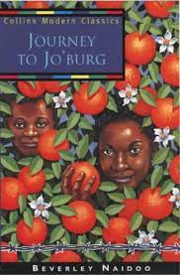  Journey to Jo’burg – Beverley Naidoo  Citizenship  Relationships | Cicada – Shaun Tan  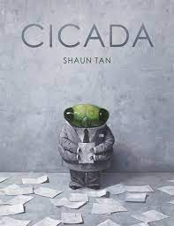  Mental health and wellbeing | 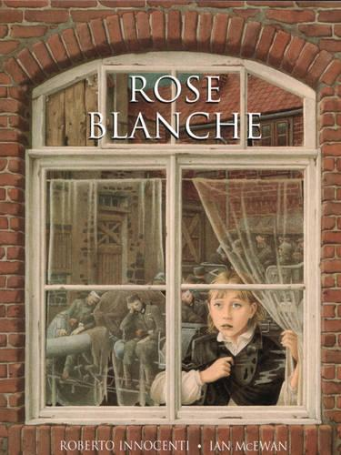  Rose Blanche – Ian McEwan  Citizenship  Economic Wellbeing | Extracts from The Diary of Anne Frank  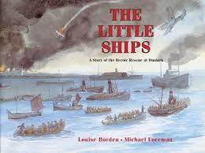  The Little Ships  Citizenship | Selection Greek Myths  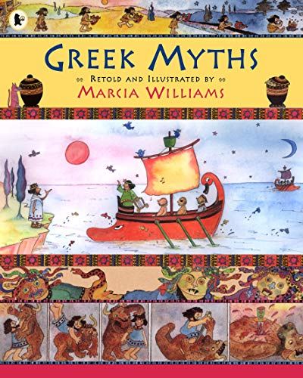  Citizenship | 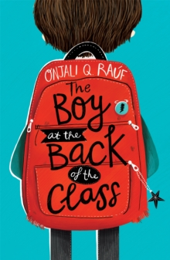  The Boy at the Back of the Classroom  Citizenship  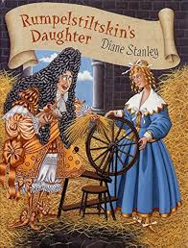 Rumplestiltskin’s Daughter  Relationships  Mental health and wellbeing  Economic wellbeing
Writing Purpose & Outcomes | Additional ‘chapter’ for the novel to entertain  Persuasive text – Why is apartheid wrong? | Narrative writing to accompany Cicada.  Life Cycle of a cicada  Voice over for David Attenborough  Explanation text - Cyclical diagrams – life cycles  Transcript – David Attenborough | Play script to allow a group of actors to perform collaboratively  Incidental writing: descriptive, diary, letter, 1st person recount | Captains log ‘  Narrative – describing the rescue mission in first person  War poem  Write to Anne Frank | Write own battle scene for a myth  Oracy focus – performance of Theseus and the Minotaur | Formal letter to a parent  Ahmed’s journey – 1st person narrative  Additional extract – how the princess tricked the king.
Class Read | The Angel of Nitshill Road by Anne Fine  Relationships  Mental health and wellbeing | Bill’s New Frock  By Anne Fine  Citizenship  Relationships | Goodnight, Mister Tom  By Michelle Magorian  Relationships | Goodnight, Mister Tom  By Michelle Magorian  Citizenship | A range of Greek myths: Pandora’s Box, King Midas, Icarus & Daedalus, Perseus  The Lion, the Witch & the Wardrobe | How To Be More Hedgehog  Anne-Marie Conway  Online Safety  Mental Health & Wellbeing
Additional Thematic Reading – guided reading | A Long Walk to Freedom – children’s version of the life of Nelson Mandela  The Enormous Turnip (link to forces) | Non-fiction - life cycles  Life cycle poetry  Just So Stories – Rudyard Kipling | Non-fiction WWII  Boy in the Striped Pyjamas (GD)  Letters from a Lighthouse | Non-fiction on WWII  The Lion and the Unicorn  Carrie’s War | Earth and Space – Clare Llewellyn  Current reports on space exploration
Ready Steady Read Together | We are family  Between Worlds  A world of flavour  Bright Bursts of colour  Secrets of a sun king  Against the odds | Wicked World  Wonder  Coming to England  Where my Wellies take me  The Goldfish Boy  Knowledge Encycolpaedia Space | A poem for every night of the year  The Explorer  The Moon  The Highway  October October  3 Lionesses | Tiger Tiger Burning Bright  Storm Keeper’s Island  A Romani Story – A different kind of freedom  Inside out and Back Again  Sky Song  Magic Your Mind Happy | Fia & the Last Snow Deer  The Nowhere Emporium  Mythologica  Utterly Brilliant Poetry  Kick  Encylopaedia of Ugly Animals | Ballet Shoes  Windrush Child  100 Best Poems  No Ballet Shoes in Syria  Sports Legends  Alice in Wonderland
Maths | Place Value  Addition  Subtraction | Multiplication & division  Factors / multiples  Fractions (equivalent) | Add & subtract fractions  Multiplication (4 digits x 2 digits)  Division (4 by 1) | Decimals  %  Area / perimeter | Graphs / tables  Shape 2D & 3D  Angles  Position / direction / coordinates | Decimals – 4 rules  Negative numbers  Measure (converting)  Volume
Science | Forces A1-5, I1-3 | Life Cycles A1-5, E1-6  Relationships | Changing Materials | Changing Materials | Space  Citizenship | RSE  Mental health and wellbeing  Relationships
Computing | Computing systems and networks - systems and searching | Creating media  Video Production  Online Safety | Programming A – Selection in physical computing | Data and information – Flat-file databases | Creating media - Introduction to vector graphics | Programming B – Selection in quizzes
Art | Art – Architecture – Printing – African Patterns  Citizenship |  | Art – Every picture tells a story – focus on Paul Nash  Citizenship |  |  | Art – Design for purpose – focus on Henry Moore – sculpture  Citizenship
DT |  | Sewing - a soft toy |  | DT – structures  Temples  Citizenship | DT – Food technology – Greek food  Online Safety  Economic Wellbeing
History |  |  | History WWII  Mental health and wellbeing  Citizenship | History WWII  Relationships  Citizenship  Economic Wellbeing | History – Ancient Greece  Relationships  Citizenship
Geography | Climate Zones | European study | European study |  |  | Mountains  Mental health and wellbeing  Relationships  Citizenship  Economic Wellbeing
Music | Clarinets & Guitars  Singing  Drumba
RE | Sikhism – how far would a Sikh go for his / her religion?  Relationships  Citizenship  Economic Wellbeing | Christianity – the Christmas story – is it true? | Sikhism – Are Sikh stories important today?  Citizenship | Christianity – how significant is it that Christians believe that God intended Jesus to die? | Sikhism – what is the best way for a Sikh to show commitment to God?  Relationships  Citizenship | Christianity – what is the best way for a Christian to show commitment to God?  Citizenship
PE | Drumba – Mine Craft  OAA (coaches) | Swimming | Yoga Mental health and wellbeing  Dance | Invasion Games  Drumba | Athletics | Striking & Fielding Relationships  Drumba
Spanish | Places in town | Hobbies / activities | Food | Dates / Weather / Easter | Seasons / Clothes | Spain / Antonio Gaudi
RSHE  Condensed Kapow | Families & Relationships (Kapow) 2-6, 8  Relationships | Bullying  Mental health and wellbeing  Relationships  Online Safety | Citizenship (Kapow)1,4,6  Copyright  Citizenship | Health and well-being (Kapow) 2, 5-7  Mental health and wellbeing  Online Safety | Economic Wellbeing (Kapow)3-5  Reputation  Relationships  Citizenship  Economic Wellbeing | Safety & the Changing Body (Kapow) 3-6  Relationships
My Happy Mind | Meet Your Brain  My Happy Mind Places | My Happy Mind Places  Celebrate | Appreciate  Healthy Lifestyles | Relate  Friendships  Families and Close Positive Relationships | Engage | Economic Wellbeing  Ourselves – Growing and Changing – Grief  Ourselves – Growing and Changing – Transition  RSE
LTE | Maps  What has happened to Lulu? | Tree  Snowmen | Hole  The Visitor | Rabbits  Conquerors | Why  Shoes | Staircase  Bear  Refugees
Oracy Outcomes | Give a speech against apartheid.  Black History Month | Voice over for video | News broadcast – outbreak of war – address the nation | Class assembly | Performance poem  Debate – should the UK allow more refugees to enter the country? | KS2 End of year production
Enrichment | Twycross Zoo | Visit to Atwell Farm Park  Visit to St Peter’s – Christingle | Into University WIAU | Holocaust Visit  Visit to St Peter’s – Easter celebration | Focus day – Into University – Ancient Greece | Cleethorpes  Theseus & the Minotaur

