Year 4 | Autumn 1 | Autumn 2 | Spring 1 | Spring 2 | Summer 1 | Summer 2
Theme | Vikings | Rivers | Romans | Victorians | Local area | Rainforests
Core Text | Arthur and the Golden Rope  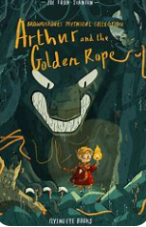  Citizenship | Cloud Tea Monkeys  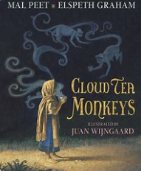  Economic Wellbeing | The Lost Happy Endings  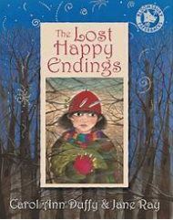  Citizenship | Alice in Wonderland  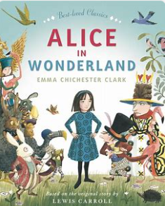  Mental health and wellbeing | 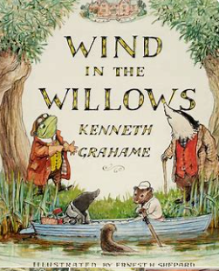  The Wind in the Willows  Relationships | The Day I Was Erased  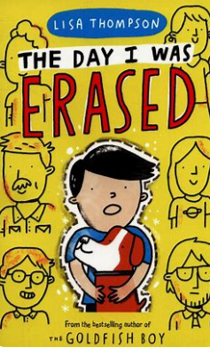  Relationships
Outcomes | •Narrative – Alternative ending  Poetry - Kenning Poems | Non-fiction Non-chronological report (tea)  Persuasion- Tea advert | Non-fiction - Information booklet (woodlands)  Narrative – Scary setting description | Retell/Recount - Diary as Alice –(up to the fall down the hole).  Instruction | Persuasion - Informal letter of persuasion  Poetry –free verse | Narrative – diary entry  Debate
Class reading | Odd and the Frost Giants – Neil Gaiman  Non fiction Vikings texts  Norse myths and legends | Tiger Tiger – Lynne Reid Banks | Roman myths - Romulus and Remus etc. | Street Child – Berlie Doherty  Velventeen rabbit – Margery Williams  Non fiction – Victorians  Oscar Wilde stories for children | The day I was Erased  Non fiction – animals and habitats, classification of living things (EPIC). | The Day I was Erased  The Explorers – Katherine Rundell  The Dark – Lemony Snickett
Reading (Ready Steady Read together)  Fiction  Non-fiction  Poetry | Viking Boy  Land of roar  Gargling with Jelly  Odder  Start to Cook  You can do Anything | Jimmy at the River School  Stories from Around the World  Poems from a green and blue Planet  Pocket book of pocket poems  The Travel Book  F2 Ultimate Footballer | When life gives you mangoes  The Last Bear  Quiz yourself clever  How to spaghetti your dog  Cherry moon  Over to you | The songwriter  Beowulf  You can do anything  Kids vs adults Ultimate quiz book  Love that dog  The complete nonsense of Edward Lear | The Boy at the back of the class  African and Caribbean Folktales, Myths and Legends  Where Zebras go  The Last Words  42 Artists everyone should know  Atlas of ocean adventure | And everything will be glad to see you  Werewolf Club rules  Make your own magic  100 forest school activities  The girl who stole an elephant  The legend of podkin one ear
Maths | Place Value (Read and write 4 digit numbers)  Place Value (Compare, order, round)  Add and Subtract 4 digit numbers | Area  Multiplication and Division | Multiplication and Division (written method)  Length and Perimeter | Fractions 1  Fractions 2 | Decimals 1  Decimals 2  Money | Time  Geometry- angles, shapes, symmetry  Statistics  Geometry- position and direction
Science | Sound | States of Matter  water cycle | Animals including humans digestion, teeth, food chains.  Relationships | Electricity | Which animals and plants thrive in our locality?  Living Things and their Habitats | Which animals and plants thrive in our locality?  Living Things and their Habitats  Citizenshipship
Computing | 4.1 Coding  Health  Online Safety  Mental Health ad Wellbeing | 4.3 Spreadsheets  Information  Online Safety | 4.5 Logo | 4.6 Animations  4.8 Hardware Investigators | 4.4 Writing for Different Audiences  Online Safety | 4.4 Making Music  Privacy  Mental Health and Wellbeing
Art | Art – Buildings / Monoprints (William Fothergill)  Citizenshipship |  | Art – Landscapes / Mixed media collage (Utagawa Hiroshige)  Citizenshipship |  |  | Art – Life Drawing / sculptures (Jackie Morris)
D&T |  | D&T – Designing packaging for ‘Cloud Tea’  Mental Health and Wellbeing |  | D&T – making biscuits | D&T –Nightlights (with Science recap for electricity)
History | The Vikings  Were the Vikings always victorious and vicious?  Economic Wellbeing |  | The Romans  Why were the Romans so powerful and what did we learn from them?  Economic Wellbeing | The Victorian Era  How did the Victorian period help to shape  the Nottingham we know today?  - Local study on Victorians  Citizenship
Geography |  | Rivers  How would we survive without water?  Economic Wellbeing  Citizenship |  |  | Local Area  What changes would we like to see in our local area?  How has Radford changed?  Citizenship | Rainforests  What is a rainforest and why are they so important?  Citizenship  Economic Wellbeing
Music | Unit: Drumba  Strength and power Intermediate rudiment skills | Unit: Recorder  The Basics: holding instrument/hand placement, parts of a recorder, timing.  Learn short song: Hot cross buns. | Unit: Drumba  Sequencing and note values | Unit: Recorder  Play short songs susing notes B, A and G, timing | Unit: Drumba  Strength and power Intermediate rudiment skills  Sequencing and note values | Unit: Recorder  Play short songs susing notes B, A and G, timing
RE | Buddhism  “Is it possible for everyone to be happy?”  Mental Health and Wellbeing | Christianity  “What is the most significant part of the nativity story for Christians today?”  Relationships | Buddhism  “Can the Buddha’s teachings make the world a better place?”  Citizenship | Christianity  “Is forgiveness always possible for Christians?”  Relationships | Buddhism  “What is the best way for a Buddhist to live a good life?”  Citizenship | Christianity  “Do people need to go to church to show they are Christians?”  Mental Health and Wellbeing
PE | Yoga  OAA | Swimming | Drumba – beat and burn  Gymnastics | Invasion Games  Yoga | Drumba  Athletics | Real PE dance  Striking and Fielding
Spanish | Introducing myself | Family and Christmas  Relationships | Classroom | Goldilocks | Habitats | At the Café’
RSHE | Family and relationships  - Respect & manners  - Healthy friendships  - How my behaviour affects others  - Bullying  Stereotypes (gender and disability  Relationships | Family and relationships  - Families in the wider world  - Loss and change  Health and wellbeing  - Diet and dental health  - Visualisation  - Celebrating mistakes  - My role  Relationships  Mental Health and Wellbeing | Health and wellbeing  - My happiness  - Emotions  - Mental health  Economic wellbeing  - Spending choices/value for money  - Keeping track of money  Looking after money  Mental Health and Wellbeing  Economic Wellbeing | Economic wellbeing  - Career and aspirations  - Influences on career choices  - Jobs for me  Economic Wellbeing | Citizenship  - Contributing  - Diverse communities  - Local councillors  Citizenship  - What are human rights?  - Caring for the environment  - Community  Safety and the changing body  - Online restrictions  - Share aware  Basic first aid  Citizenship  Online Safety | Safety and the changing body  - Privacy and secrecy  - Consuming information online  - First Aid: Asthma  - Growing up  - Growing up  - Introducing puberty  - Tobacco  Transition  Setting goals  Bullying  Online Safety  Mental Health and Wellbeing
My Happy Mind | Meet Your Brain  My Happy Mind Places | My Happy Mind Places  Showing respect and managing hurtful behaviour  Celebrate | Appreciate  First Aid  Media Literacy and Digital Resilience | Relate  Safe Relationships | Engage  Keeping Safe | Economic Wellbeing (3)  Ourselves – Growing and Changing – Transition (1)  RSE
LTE | Wolves – Emily Gravett (classification of fiction and non fiction texts)  Relationships | The Red Tree– Shaun Tan  Mental Health and Wellbeing | Tadpole’s Promise – Jeanne Willis and Tony Ross  Relationships | The Little Boy and the Old Man– Shel Silverstein  Relationships  Relationships | Not Now Bernard – David McKee  Relationships | Here We Are – Oliver Jeffers  Economic Wellbeing  Citizenship  Relationships
Oracy outcomes | Read narrative fand kenning poemsrom the English unit to Year 5 | Read non-chronological report on tea to parents during Tea Tasting Party  Black history presentation alongside school. | Perform drama piece on taking care of the teeth for Year 2 | Victorians presentation and biscuits tasting with parents. |  | Debate before parents and Year 5/6
Enrichment | Viking Workshop – University of Nottingham (Vikings Dept.)  Head Boy & Head Girl votes | Tea tasting Party - Reading Café (invite parents).  Trip ST Peter’s church – Symbols of Christianity and Christingle  Visit to Windmill Gardens – rivers and water cycle.  Road Safety Week | Romans – Southwell Minster  Forest school area visit  Visit to Art Exchange in Hyson Green  Safer Internet Day | Perlethorpe/ Victorian Day in school  Presentation on Victorians  Biscuit tasting with parents.  Easter Bonnet crafts and D&T competitions  British Science Week | Science - Forest School Area/Local Area walk to identify local animals  Local Area Walk to discover changes in Radford  National Numeracy Day  Maths Roadshow  Into University | Heights of Abraham  Careers Week

