Year 3 | Autumn 1 | Autumn 2 | Spring 1 | Spring 2 | Summer 1 | Summer 2
Theme | Humans and animals | Forces and magnets | Angry Earth  GEOGRAPHY MASTERY | Stone Age | Rainforests  SCIENCE MASTERY | Ancient Egyptians  HISTORY MASTERY
Core Text | The Incredible Book Eating Boy – Oliver Jeffers  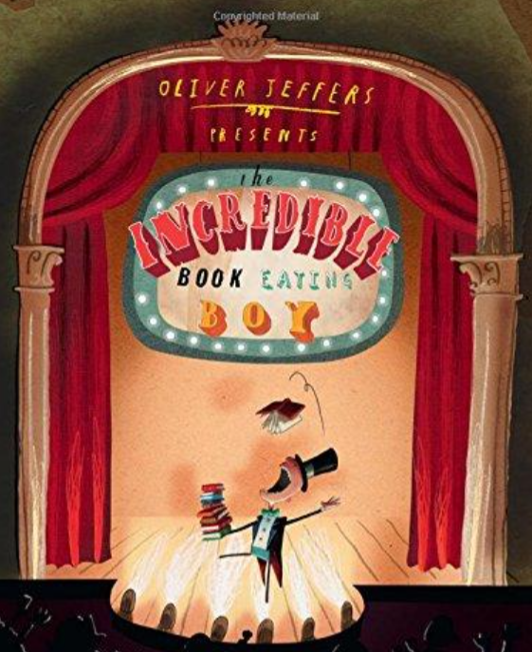  Mental health and wellbeing | The Iron Giant  The Iron Man – Ted Hughes  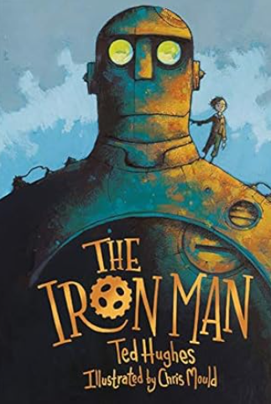  Relationships | The Three Billy Goats Gruff – Mac Barnett  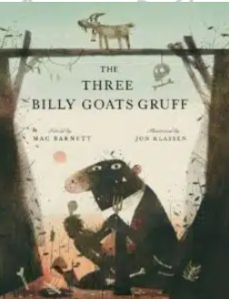  Relationships | How the Stars Came to Be – Poonam Mistry  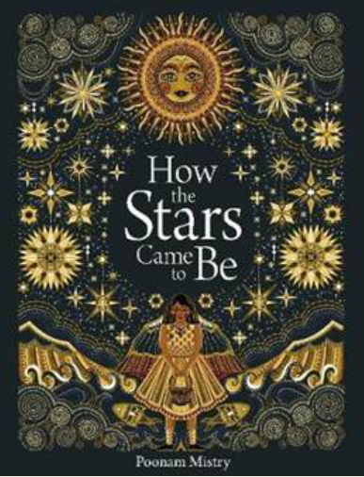  Mental health and wellbeing | The Great Kapok Tree – Lynne Cherry  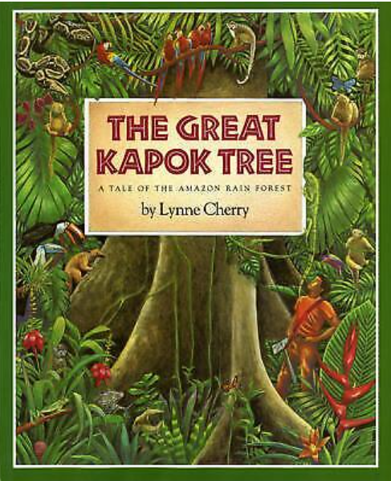  Citizenship | Marcy and the Riddle of the Sphinx  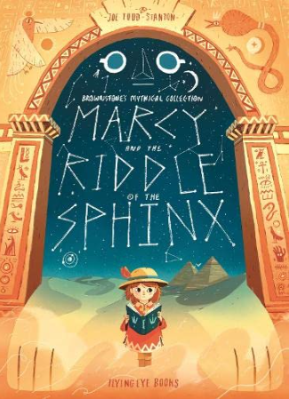  Mental health and wellbeing
Outcomes | Persuasive letter to Henry to stop eating books  Narrative – ‘The Incredible … eating boy’  To entertain the reader | Description of Iron Giant  Diary entry as Hogarth that makes the reader feel sorry for the Iron Man. | Amusing description of the troll.  News report on a tsunami event to inform the reader. | Description of how ‘The Girl’ placed the stars in the sky that makes the reader feel amazed.  List poem of the stars in the sky. | Non-chronological report on jaguars  Narrative – first person description of an event in the story | Narrative - adventure sequence  Newsflash report – what happened when Howard Carter discovered the tomb.
Class read | The Wild Robot  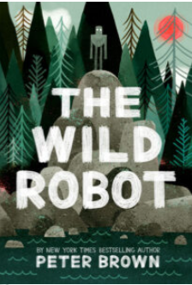  Relationships | The Iron Man  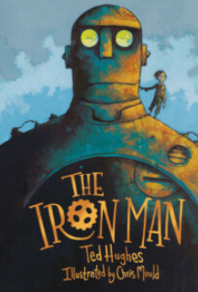  Relationships | Escape from Pompeii  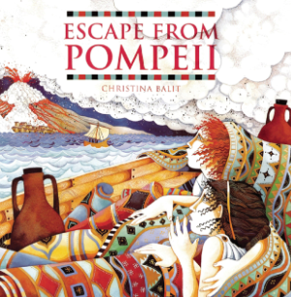  Citizenship | Varjak Paw  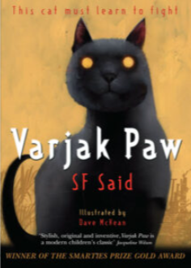  Relationships | The Thing About Bees: A Love Letter by Shabazz Larkin  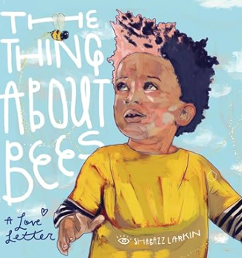  Citizenship | The Puffin Keeper  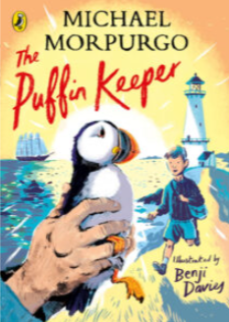  Relationships
Reading | Core text  Once Upon An Alphabet – Oliver Jeffers.  Additional Oliver Jeffers books | Core text  Iron Woman | Core text  The Firework Makers Daughter – Phillip Pullman  Non-fiction on Volcanoes and Earthquakes  Where did all the pebbles come from? | Core text  The Boy With The Bronze Axe – Kathleen Fiddler  Non-fiction on Stone Age to Iron Age. | The Shaman’s Apprentice – Lynne Cherry  Non-fiction – Rainforests. | Flat Stanley and the Great Egyptian Grave Robbery  Traditional Tales  Non-Fiction Egyptians
Ready Steady Read | Harry the Poisonous Centipede  The One and Only Ivan  The Lego Ideas Book  The Wonders of Nature  Welcome to My Crazy Life  A World Full of Poems | Rumaysa  The Wild Robot  Explore  The Usborne Beginner’s Cookbook  Ted Hughes collected poems  Cloud Busting | The Last Firefox  Charlotte’s Web  Usborne complete book of art ideas  An Anthology of Intriguing Animals  Quick, let’s get out of here  Hot like fire and other poems | Hello, Universe  How to train your dragon  My Encyclopedia of very important science  My very important human body encyclopedia  A whale of a time  When poems fall from the sky | The day I fell into a fairytale  Varjak Paw  Hamza’s Wild World  Feather Flower Forest World  Pick and Mix Poetry 1  I am the seed that grew a tree | The wonder brothers  Danny Chung does not do maths  There’s no such thing as a silly question  The funny life of football  Classic poems  Pick and mix poetry 2
Maths | Place Value to 1000  Addition and Subtraction | Multiplication and Division | Multiplication and Division  Measurement and Perimeter | Fractions  Mass  Capacity | Add and Subtract fractions  Money | Time  Angles and Properties of Shapes  Statistics
Science | Big Question: why do living things need to eat and how does it help us?  Animals including Humans  Windmill Gardens  Use Forest School | Big question: What are forces?  Forces and magnets | Big question: How did all the pebbles get there?  Rocks and soils  Windmill Gardens |  | Big Question: why is pollination important for the survival of plants?  Plants | Big question: How does light help us to see?  Light
Computing | Computing systems and networks – Connecting computers  Online safety | Creating media – Stop frame animation  Online safety | Programming – Sequencing sounds  Online safety | Data and Information – Branching databases  Online safety | Creating media – Desktop publishing  Online safety | Programming – Programming quizzes  Online safety
Art |  | Printing |  | Stone Age Art  citizenship | Knowledge of art from different cultures and times  citizenship
D&T | Cooking and nutrition – Pizza  Invite parents to sample pizzas  Mental health and wellbring |  | Moving pictures, levers |  |  | Textiles  Design and make Egyptian jewellery or clothing
History |  |  |  | Stone Age to Iron Age  Visit to Lakeside Museum  Keynote presentation to Year 2 |  | Ancient Egypt  Entry point – Partake theatre  Mastery – Egyptian Museum. Link to D&T / Art Sculptures.
Geography |  | North America  citizenship | Volcanoes and Earthquakes  Mastery Day – Documentary on Volcanoes |  | Brazil and Rio  citizenship
Music | Recorders  Singing | Drumba  Singing | Recorders  Singing | Drumba  Singing | Recorders  Singing | Drumba  Singing
RE | Big Question: Would celebrating Diwali at home and in the community bring a feeling of belonging to a Hindu child?  Hinduism | Big Question: Has Christmas lost its true meaning?  Christianity | Big Question: Could Jesus heal people?  Were there miracles or is there some other explanation?  Christianity | Big Question: What is ‘good’ about Good Friday?  Christianity | Big Question: How can Brahman be everywhere and in everything?  Hinduism | Big Question: Would visiting the River Ganges feel special to a non-Hindu?  Hinduism
PE | Yoga  OAA | Swimming | Drumba  Gymnastics | Dance  Invasion Games | Athletics  Yoga | Drumba  Striking and fielding
Spanish | Core vocabulary for days of the week, months of the year, and colours  Phonics unit | I’m learning Spanish Unit | Fruits | Ancient Britain | Little Red Riding Hood | Animals
RSHE | Mental Health and Wellbeing | Mental Health and Wellbeing | Mental Health and Wellbeing  Safer internet day | Relationships | Mental Health and Wellbeing  Citizenship | Mental Health and Wellbeing
My Happy Mind | Meet our brain  My Happy Mind Places | My Happy Mind Places  Celebrate | Appreciate  Healthy Lifestyles | Relate  Friendships  Families and Close Positive Relationships | Engage  Shared Responsibilities  Communities | Ourselves – Growing and Changing – Grief  Ourselves – Growing and Changing  Transition  RSE
LTE | Harris Burdick mysteries | Tunnel | Journey | Quest | Return | Fidgety Phillip  Blue and yellow
Oracy outcomes | Class assembly |  |  |  |  | Presentation to parents and other children for Egyptian Museum.
Enrichment | Animal handling workshop - meet a creature  Head Boy & Head Girl votes  ‘Thrive’ Keeping Healthy workshops  Class assembly with parents invited | Pantomime  Christingle at St Peters  Road Safety Week | Volcanic eruption  Safer internet day  Windmill Gardens – Rocks and Soils | Cresswell Crags  Easter Bonnets Craft with Family  Science week | Sounds of the rainforest  Windmill community gardens  National Numeracy Day  Maths Roadshow  Hindu Temple Visit | Partake theatre - Ancient Egyptian day  Careers week  End of year trip – Sealife Centre

