Year 2 | Autumn 1 | Autumn 2 | Spring 1 | Spring 2 |  | Summer 1 | Summer 2
Theme | Space and Explorers  Add mastery outcomes | Great Fire of London | Africa | What would you find in the woods? |  | Hot and cold places | Our local Area  (Medieval Nottingham)
Core texts | 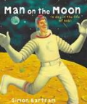  Man on the Moon | 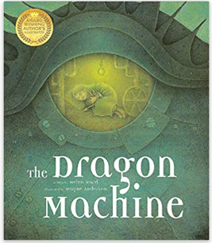  The Dragon machine  Mental health and wellbeing | Lila and the secret of the Rain  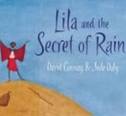  Citizenship | 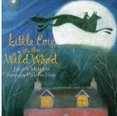  Little Evie in the wild wood  Relationships |  | Paddington  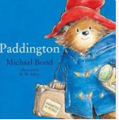  Relationships | Robin Hood  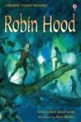  Citizenship
Writing purposes and outcomes | A Narrative about Bob’s Morning to entertain the reader  A description of the aliens. To inform the reader | Narrative – about the beginning of a story.To entertain the reader  Descriotion- about what the dragon machine looks like. To inform the reader | Recount/ diary- To inform the reader  Information text ( Non-Chronological report) all about Kenya. To inform the reader | Recount/Narrative on little Evie’s journey through the wood To entertain the reader  Instructions for making Jam tarts for the wolf - to inform the reader |  | Narrative – Padidngtons journey in London To entertain the reader  Email- to Aunt Lucy- to inform the reader | Sherwood Forest leaflet- to persuade the reader  Narrative- making our own Robin Hood story to entertain the reader  Haiku poems. To entertain the reader
Class read | 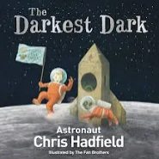  The darkest moon | 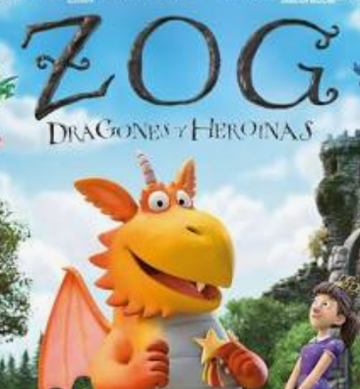  Zog | 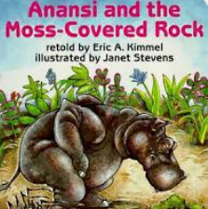  Anansi and the moss coloured rock | 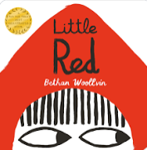  Little red |  | Other Paddington stories   | 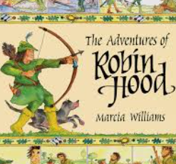  Robin Hood stories
Reading | One giant leap (Don Brown)  Exploreers: Amazing Tales of the World’s Greatest Adventurers.  (Nellie Huang)  Space Explorers (Libby Jackson)  Fly High The story of Bessue Coleman (Louise Borden)  Bessie Coleman Daring Stunt Pilot (Trina Robbins) | The Great Fire of London (Famous people, Great events)  (Gllian Clements)  The Great Fire of London (ways into History) Sally Hewitt  The Great Fire of London Start up History (Stewart Ross)  The Great Fire of London Anniversary addition of the Great Fire of 1666 (Emma Adams and James Weston Lewis) | Africa Amazing Africa, Country by Country (Atinuke and Mouni Feddag)  Collins First Atlas (Collins maps)  Weclome to our world a celebration of children everywhere (Moira Butterfield)  Introducing Africa (Chris Oxclade)  The ultimate book of African animals (National Geographic kids) | Living habitats the big picture ( Jon Richards )  Small world water (Lily Murray)  Small worlds: Earth: (Camilla De la Bedoyere)  Habitats and Food chains (Ruth Owen)  Animal Habitats (Donald Silver)  Where is my home (Lucy Parrianen) |  | Homes in cold places (Adam and James)  Homes in Hot and Cold polaces (Simon and Crisp)  Various books about Peru ELS | See Inside castles ( Usbourne Flip book).  National Georaphic Kids Everything castles  The story of castles Lesley Sims  Medieval Life (Eyewitness)
Ready Steady Read | RWI |  | Everything under the sun  Poems for every season  A world full of animal stories Africa  RWI | Grimwood  A first book of nature  A year full of stories  RWI |  | Paddington  Pinochio  Never get bored paint and draw  50 ways to score a goal  The works | Lenora Bolt Secret inventor  Illustrated stories from Aesop  A wildlife of animals  First big book of how  Midnight feasts  Puffin book of first poems
Maths | Place value | Addition and Subtraction  Shape | Multiplication and division  Money | Measurement |  | measurement  fractions | Time  Statistics  Position and direction
Science | Science- Materials and their uses | Science- Changes in materials | Science:  Animals including humans. Living Things and their habitats (Africa)  Mental health and wellbeing  Relationships | Science:  Animals, including humans  Micorhabitats  Relationships |  | Science:  Living things and their habitats (Peru)  Plants (  Relationships | Science- plants  Citizenship
Computing | Computer systems and networks IT aroud us.  E Safety  Online Safety | Digital photography  relationships  E Safety  Online Safety | Programming robot algorithms  Online Safety  Safer internet day | Data and information pictograms  Online bullying  Online Safety |  | Creating digital music  Privacy  Online Safety |  | Programming quizzes  Self image  Reputation  Online Safety
Art |  | Art- collaborative art.  Printing Great fire of London pictures | - ART- African mud huts- weaving- 3D structures.  Artist: African Culture | Art- Observational drawings  Artist: Dennis Wojtkiewiczs
DT |  |  |  | D+T- Structures making a bridge. |  | D+ T- Making a healthy meal ( Marmelaide sandwiches and preparing fruit and vegetables).  Mental health and wellbeing | D+T- designing and making a catapult
History | History- Explorers significant individuals  Citizenship  Relationships | History- The Great fire of London  Citizenship |  |  |  |  | Local study  History/ Geography- Robin Hood  Citizenship
Geography | Geography- Continents and Oceans |  | Geography- Kenya ( non European country comparison)  Citizenship |  |  | Geography- Hot and cold countries.  Citizenship
Music | Charanga/ singing | Music – Great fire of London song and performance with glockenspiels (Mastery) | Charnaga/ Singing | Charnaga/ Singing |  | Charnaga/ Singing | Charnaga/ Singing
RE | RE- Christianity  What did Jesus Teach? Is it possible to be kind all the time?  Citizenship  Relationships | RE- Christianity  Why do Christians believe God gave Jesus to the world?  Relationships | RE- Islam Does praying at regular intervals help a Muslim in his/ her everyday life?  Mental health and wellbeing | RE- Christianity  How important is it to Christians that Jesus came back to life after his resurrection?  Relationships |  | RE- Islam -Does going to the Mosque give Muslims a sense of belonging?  Citizenship | RE- Islam - Does completing Hajj make a person a better Muslim?  Citizenship
PE | Drumba – Emotion in Motion | Real PE – Personal-Footwork & Balances  Yoga  Mental health and wellbeing Physical | Real PE dance  gymnastics | Drumba  Invasion games |  | Athletics  Yoga | Drumba  Striking and fielding
Spanish | Numbers, animals, colours , special events
RSHE | Families and Realtionships / economic wellbeing  Relationships  Economic Wellbeing | Relationships  My Happy Mind Places (2  Mental health and wellbeing | Health and wellbeing  Mental health and wellbeing Keeping Safe (2)  Media Literacy & Digital Resilience (1) | Relationships  Citizenship  Mental health and wellbeing  Friendships (1) | Privacy  Relationships  Safe Relationships (2) |  |  | Relationships  Ourselves, Growing and Changing – Transition (1)  Economic Wellbeing (2)
My happy mind | Meet your brain | Celebrate (4) | Appreciate (3) | Relate (3) | Engage (4)
LTE | Journey  Relationships | Zog  Relationships | I want my hat back  Relationships | Wild  Mental health and wellbeing |  | Luna  Citizenship | The suitcase  Mental health and wellbeing
Oracy outcomes | Geography continents and oceans presentation  Space poetry pefformance | Nativity  Hot seating and role play activities- Samuel Pepys  Presentation to classes  Speak fluently in front of an audience,Maintain eye contact/ body language | Read story to a different class :Confident delivery of prepared materials  Start to develop an: awareness of audience: Project their voice to a large audience :Speak fluently in front of an audience.  Geography- Radio broadcast what is different between school in Kenya and school in the UK | Presentation to a class in the school about hoe to make jam tarts. :Speak fluently in front of an audience :Maintain eye contact/ body language |  | Paddington role play: Use topic appropriate vocabulary :Body language- to show how character is feeling : Start to develop an awareness of audience. | CLASS ASSEMBLY:Speak fluently in front of an audience,Maintain eye contact/ body language.
Enrichment | Space day- classtoom transformed into a speace ship children take a trip through the universe (Planiterium if possible.  Alien landing on the playground | GFOL Dragon in the classroom investigation.  Loan box  Church visit | Visitor – talking about living in Africa. | Community gardens looking at different plants  Walk in the woods  Use of the forest school area  Windmill gardens- Microhabitats Windmill gardens trip- plants seeds  Mosque visit  Science week |  | Paddington postcards to the class  Old suitcase enrichement lesson.  Use of I pads  Windmill gardens plants | Class assembly  Trip to Sherwood forest.

