Year 1 | Autumn 1 | Autumn 2 | Spring 1 | Spring 2 | Summer 1 | Summer 2
Theme | All about me, Black History | Autumn, Bonfire Night, City, Local Geography | Winter, Snow and Ice | Spring, Plant and trees | Vegetables, common animals | UK, The king and London
Core Text | Funny Bones  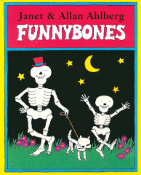  The Tiger who came to tea  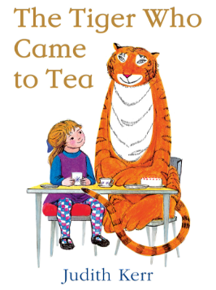  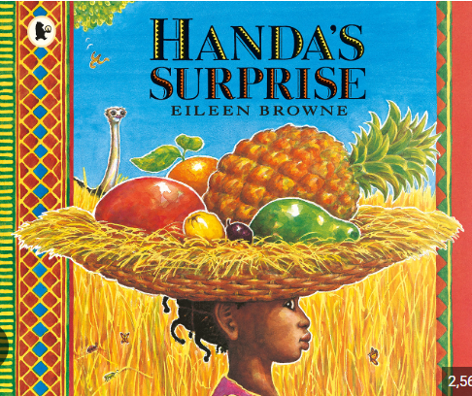  Handa’s Surprise  Online Safety | 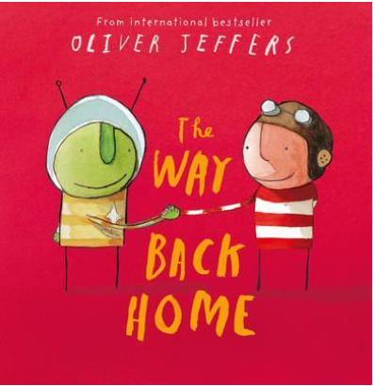  The Way Back Home – Oliver Jeffers  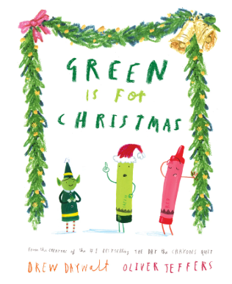  Green is for Christmas  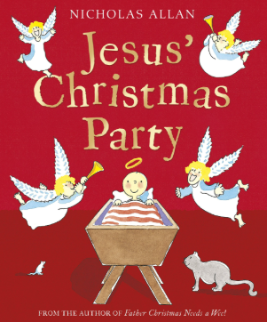  Jesus’ Christmas party  Relationships | 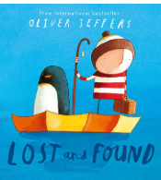  Lost and Found – Oliver Jeffers  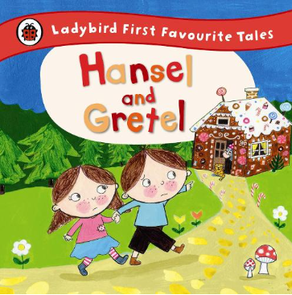  Hansel and Gretel  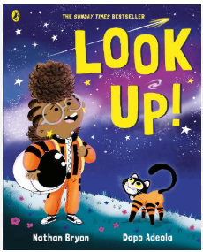  Look up  Mental health and wellbeing | 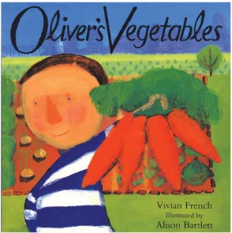  Oliver’s Vegetables  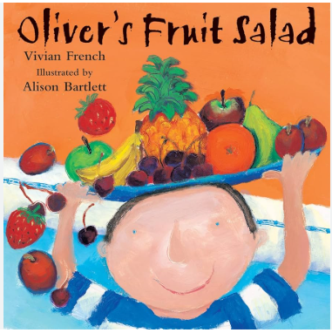  Oliver’s Fruit Salad  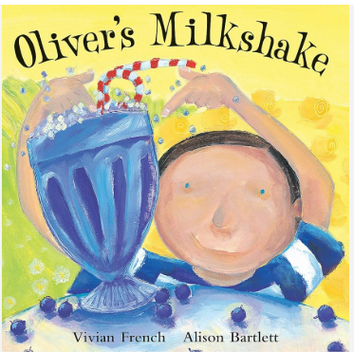  Oliver’s Milkshake  Economic Wellbeing | 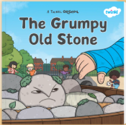  The Grumpy Old Stone  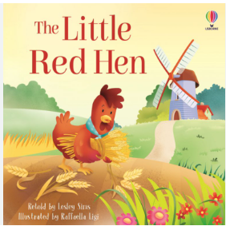  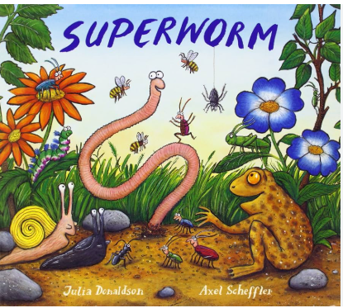  Superworm  Little Red Hen  Economic Wellbeing | The King’s Pants  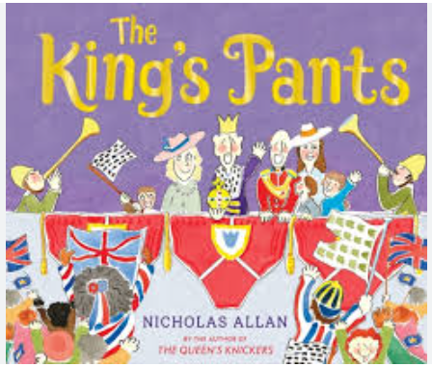  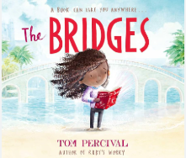  The Bridges  Citizenship
Writing Outcomes | Simple sentence writing.  Capital letters and Full stops focus. | Simple sentence writing.  Use joining word ‘and’  Capital letters and Full stops focus. | Simple sentence writing.  Use joining word ‘and, but’  Capital letters and Full stops focus. | Simple sentence writing.  Use joining word ‘and, but, so’  Capital letters and Full stops focus. | Short narrative writing  Begin to use question marks  Capital letters and Full stops focus. | Narrative writing  Punctuate sentences using full stops, exclamation marks and question marks.  Capital letters and Full stops focus.
Class read | Town Mouse and Country Mouse  Relationships | Rumplestiltskin  Relationships | Snow Queen – Hans Christian Anderson  Mental health and wellbeing | The Adventures of Mr Toad - Kenneth Grahame  Mental health and wellbeing | Other traditional tales | Mary Poppins – PL Travers
Reading/ELS | Core text  Handa’s Surprise | Core text  The Way Back Home – Oliver Jeffers  Additional Oliver Jeffers books | Core text  Lost and Found – Oliver Jeffers | Core text  Bog Baby | Core text  Olivers Vegetables | Core text  The King’s Runaway Crown
Maths | Count to and across to 20 forwards and backwards  Represent and use number bonds and related subtraction facts within 20  read, write and interpret mathematical statements involving addition (+), subtraction (–) and equals (=) signs  recognise and name common 2D and 3D shapes, including: 3D shapes |  | Count to and across to 50 forwards and backwards  Recognise the place value of each digit in a two-digit number (tens, ones)  Identify one more and one less  Addition and subtraction |  | Count to and across to 100 forwards and backwards  Multiplication (10’s, 5’s and 2’s)  Division  Fractions (halves and quarters)  Position and Direction  Time  Money
Science | Animals incl Humans  Economic Wellbeing | Animals incl Humans  Seasonal Changes (Autumn)  Economic Wellbeing | Materials  Seasonal Changes (Winter)  (Spring)  Economic Wellbeing |  | Plants and Trees  Seasonal Changes (Summer)  Economic Wellbeing | Animals incl Humans  Economic Wellbeing
Computing | Computing systems and networks – Technology around us  Online Safety | Creating media – Digital painting  Online Safety | Programming A – moving a robot  Online Safety  Safer Internet Day | Data and information – Grouping data  Online Safety | Creating media – Digital writing  Online Safety | Programming B – programming animations  Online Safety
Art | Portraits/ Printing/ Klee |  | Landscapes/ Collage/ Ted Harrison |  | Creatures/ Sculpture/ Andy Goldsworthy
D&T |  | Mechanisms  Sliders and levers  Rosa Parks moving pictures |  | Food  Dips & Dippers |  | Textiles  Finger Puppets
History | Rosa parks  Citizenship  Relationships |  | Local History  Citizenship |  |  | Kings and queens  Citizenship  Relationships
Geography |  | Local area  Economic Wellbeing |  | Weather and climate | The U.K
Music | Body percussion/singing | Body Percussion/singing | Drumba/singing | Drumba/singinig | Drumba/singing | Drumba/singing
RE | Christianity – Creation Story  Relationships  Citizenship | Christianity – Christmas  Citizenship  Relationships | Christianity – Jesus as a friend  Citizenship  Relationships | Easter- Palm Sunday  Citizenship  Relationships | Judaism - Shabbat  Citizenship  Relationships
PE | Drumba- Flow and Focus  Coach- OOA | Real PE- Personal  Footwork and Balance  Coach- Yoga | Real PE- Dance  Coach- Gymnastics | Drumba  Coach- Invasion Games | Real PE  Coach- Athletics | Drumba  Coach- Striking and Fielding
MFL | Spanish
RSHE | Mental health and wellbeing | Relationships  Mental health and wellbeing | Mental health and wellbeing | Relationships | Citizenship  Mental health and wellbeing | Mental health and wellbeing
My Happy Mind | Meet Your Brain (5) | My Happy Mind Places (2)  Celebrate (4)  Relationships- Showring respect and managing behaviour (1) | Appreciate (3)  Healthy Lifestyle (2) | Relate (3)  Families and positive close relationships (2) | Engage (4)  Shared responsibilities (1) Communities (1) | Ourselves, Growing and Changing, inc transition (3)
LTE | Where do I live? – EY Turq | Senses – EY Turq  Crossroads - Blue | Lost Boot- EY Blue  Cat and Snail – Blue | Living? – Blue  Cooking - Blue | Farmyards – Blue  Bear - LTE | Ice cream Story – Blue  Hat - LTE
Oracy outcomes | Present all about me boxes to class. | KS1 Nativity | Share own stories to EYFS. | Share active learning outcomes with parents.
Enrichment | Access Artefacts – Box of Toys  Rosa Parks Assembly | Windmill Community Gardens – making pumpkin soup  Christinge at St Peters Nativity  Anti Bullying Week | Ice world, built in outside area to explore.  Nottingham Castle | Forest School visits  Easter Bonnets Craft with Family  Wild Things - teddy bears picnic. | Windmill Community Gardens  National Numeracy Day | Tea Party on the school field.  Woodside Wildlife Park

