 | Radford Academy Reception EYFS Long Term Plan
 | Autumn 1` | Autumn 2 | Spring 1 | Spring 2 | Summer 1 | Summer 2
Main Topic/Theme | Nursery Rhymes  All about Me | Superheroes  Celebrations | Julia Donaldson Stories | Traditional Tales | Things that grow  Minibeasts | Down on the Farm  Weddings
Continuous provision  (will be in provision all year round and enhancements will be added) | Train track – small figures – small blocks  Lego – mobile – block play  Cubes – dominos – numicon – shapes – magnetic numbers  Whiteboards and pens – post-it notes – coloured paper – blank notebooks – pencils – pens – felts – magnetic letters  Collage material – glue sticks – scissors – selotape – colour pencils – paint and brushes – coloured and plain white paper  Home corner  Large construction – blocks, planks and crates  Water tray – bowls – measuring jugs – pippets – sponges  Sandtray – buckets – spades –
Texts | 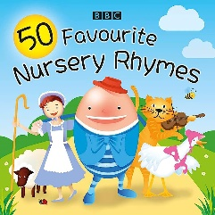  Humpty Dumpty  Wind the bobbin up  1,2,3,4,5  Polly put the kettle on  I’m a little teapot  Twinkle Twinkle  Titch  Super Duper You!  Funnybones | 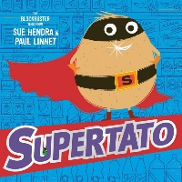    Supertato selection  The story of Rama and Sita  Dear Santa  That’s Not My... | 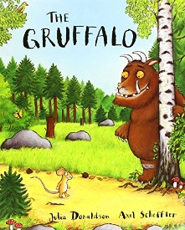  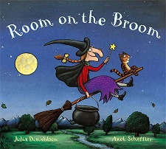  The Gruffalo  Room on The Broom  The Smeds and Smoos  Stickman  Zog  Smartest Giant in Town  A Squash and squeeze | 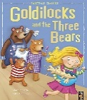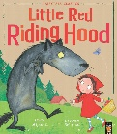  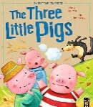  Little Red Riding Hood  The Three Little pigs  Goldilocks and the three Bears  The Enormous Turnip | 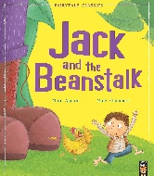  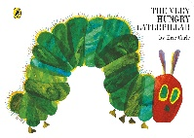  Jack and the Beanstalk  The Very Hungry Caterpillar  The crunching Munching Caterpillar | 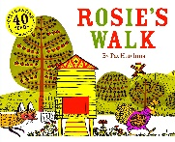  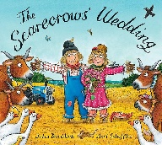  Rosies Walk  What the ladybird heard  The Scarecrow’s Wedding
Roleplay provision | Outdoor – Hospital  Playdough area | Shoe shop  Christmas bakery | Potions lab / Pizza takeaway / Chinese takeaway | Three Bears Kitchen  Bakery / cake shop | Flower shop  Potting shed – greenhouse | Café  Ice-cream parlour
Key vocabulary taught  (adults model in context and children use) | Delicious  Disgusting  Curious  Confident  Celebrate |  | Tradtional  In the past  In the future  Magnetic  Predict  Notice |  | Gigantic  Minute  Antennae  Minibeast  Udder
Small World Provision | Humpty Dumpty’s Wall  Nursery Rhyme Characters/puppets and back grounds | Rama and Sita Puppets  JCPM puppets and blocks  Christmas tree and decorations | Gruffalo small world  Room on the Broom Small world | Small world puppets and story sacks for  Three little pigs  Goldilocks  Jack and Beanstalk  Red Riding Hood | The Very Hungry Caterpillar Story Sack  Fruit and baskets | Rosies walk smallworld  Farm animals
Communication and Language | In the first term children will be baselined  The activities and enhancements in the setting encourage children to work and play alongside each other to develop their relationships, manage their behaviour and negotiation skills and to communicate effectively with each other.  Their will be focused ‘Rhyme time’ and story time and adults will work with children (alongside and not always directing) to model and assess these goals. | Children retell the stories they have heard, sing Christmas songs and perform in the Nativity | Retell the Chinese New Year story  In small world – retells the stories heard in class using story language | In small world – retell the stories heard in class using story language  In adult supported and group activities children will be encouraged to develop their questioning skills using stimuli at throughout the topic. Adults will use stem sentences to encourage new language based on the text, topic or theme  Weekly Rhyme time will encourage the repetition of rhyme and song in children’s play and interventions will support children (NELI Language programme) will support children who need it.
Personal, social and emotional |  | My Superpowers would be…children discuss what powers they would have  Children work together to ‘save’ each other as they act as super heroes. |  | Children will develop their interpersonal skills over time with guidance and modelling from the adults in class, sharing toys, turn taking in games, helping peers, problem solving. The activities and enhancements in the environment will be selected to develop these skills and interventions e.g. interactive music will support children who a falling behind.
Physical development | Fine motor  Pencil and scissor holding –  Threading - manipulating and balancing blocks  Rolling and pressing playdough to make shapes  Balancing on the trim trail – moving crates and blocks – running in a straight line – throwing a catching a ball | Superhero Obsticle course  Wrapping gifts- scissor skills  Make a sleigh for Santa |  | Activities in all areas will support the Children’s gross motor and fine motor skills. E.g. the use of following step by step instructions to create pictures of animals and then painting them. The focus on handwriting in phonics.  Children will have access to the trim trail and large play equipment outdoors and the PE scheme develops children’s balance and agility.
Literacy | Name writing practice  Writing names on all pieces of work  Labelling activities  Initial letter sounds for family members  Mark making – drawing circles, zigzigs, wavy lines, updown lines and side to side lines | Christmas lists to Santa  Write labels for presents  Write cards to each celebration | Retell their own simple versions of the stories adding captions to pictures  Labeling parts of the animals  Writing in speech bubbles  Writing a simple spell | Simple rewrite – of the stories using ‘first, next, then’  Recipe for ‘how to make porridge’ including simple modal verbs  Simple description of houses they live in  How to plant a magic bean  Create simple story maps | Retell the story of the VHC making them the caterpillar and creating their own fruit to eat.  Caption writing following the changes of the caterpillars in class  Minibeast information books  Create story maps | Tell their own version of a walk using positional language  Farm animal information books  Wedding invitations  Recount of farm visit
Mathematics | Numbers 0,1,2,3  Understanding the language numeral and representation  Subatizing to 3  Ways to make up to 3  Exploring pattern and repeating patterns | 4, 5 and 6  Numbers that make 5 begin to learn off by heart | 7 and 8  Ordinal numbers linked to Chinese New Year | 9 and 10 | Doubles and halves  Butterflies and ladybirds | Number patterns – looking at counting in 2’s and 10’s
Understanding the world | Family tree – who came before me  My favourites – I like – I don’t like  My senses  Real life humpty dumpty eggs – how to keep him on the wall | RE – Diwali – The Christmas Story  Evil Pea Jelly  Visits from the Fireservice/police/vets  Discuss celebrations – how we celebrate now and how our parents/grandparents celebrated – look at what is the same and what is different | Animal habitats  Visit to the forest school to look at the ‘underground house’ ‘Tree top house’  Explore the celebration of Chinese new Year – Look at China and how it is similar/different to where we live  Make potions and observe the changing states when substances are mixed together | Design a healthy lunch  Explore materials and their properties (three little pigs)  Create a house that cannot get blown down  Plant a magic bean and create the best conditions for it to grow | Real life caterpillars in the classroom – life cycles  Minibeast hunt – visit to windmill gardens  Create a minbeast hotel  Eid celebration day | Visit to a farm and allotment  Have eggs and an incubator in school to watch the chicks hatch – life cycles  Go on our own ‘Rosies walk’ to look at features of our local environment
Expressive arts and design | Self portraits  Skelton pictures using paper straws  People biscuits  Colour mixing/rainbows | Firework pictures  Firework models  Rangoli Patterns  Make a Superhero Cape  Make a SuperTato  Christmas Cards and decorations | Step by Step how to draw a Gruffalo…Dragon etc  Make a playdough Gruffalo  Make a Gruffalo cake  Collage the animals in the story choosing colour and texture to match each character | Playdough pigs  Make porridge for the three bears  Make a wolf face plate  Create a bear puppet | Saltdough minibeasts  Step by step how to draw a minibeast  Eggbox caterpillars  Minibeast collage | Learn the step by step how to draw a pig/sheep/cow/chicken
Enrichment | Visit from a baby – make timelines of ourselves. | Visit to the local shop  Perform the Nativity  Visit from Santa  Christingle at St Peters Church  Trip to the cinema | Forest School – Gruffalo animal habitats  Perform Chinese New Year story assembly | Easter Bonnet Parade  Visit to St Peters Church  *Parent visit to describe their cultural origins.  *this may happen in another term. | Have caterpillars in the class, watch them grow and change into butterflies.  Visit the forest school to go on a minibeast hunt | Visit to the farm.  Have a Reception class wedding.

