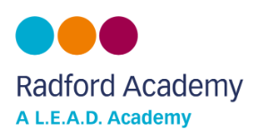

Child Friendly Version of our Safeguarding Policy
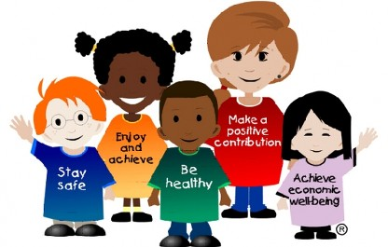

What is Safeguarding about?

All of the adults at Radford Academy think that your health, safety and welfare are very important.
In our school we respect our children and help to protect their rights.
We do our best to help children make excellent educational progress.
We teach children how to recognise risks in different situations and how to protect themselves and stay safe.

How will we try to safeguard children?

We try to provide a safe environment for children to learn in.
We want to help to ensure that children remain safe, at home as well as at school.
We think it is important for our children to know where to get help if they are worried or unhappy about something.

What should children do?

Speak to an adult at school if you are worried about something.

Need to talk at any time – remember you can talk to ChildLine:
