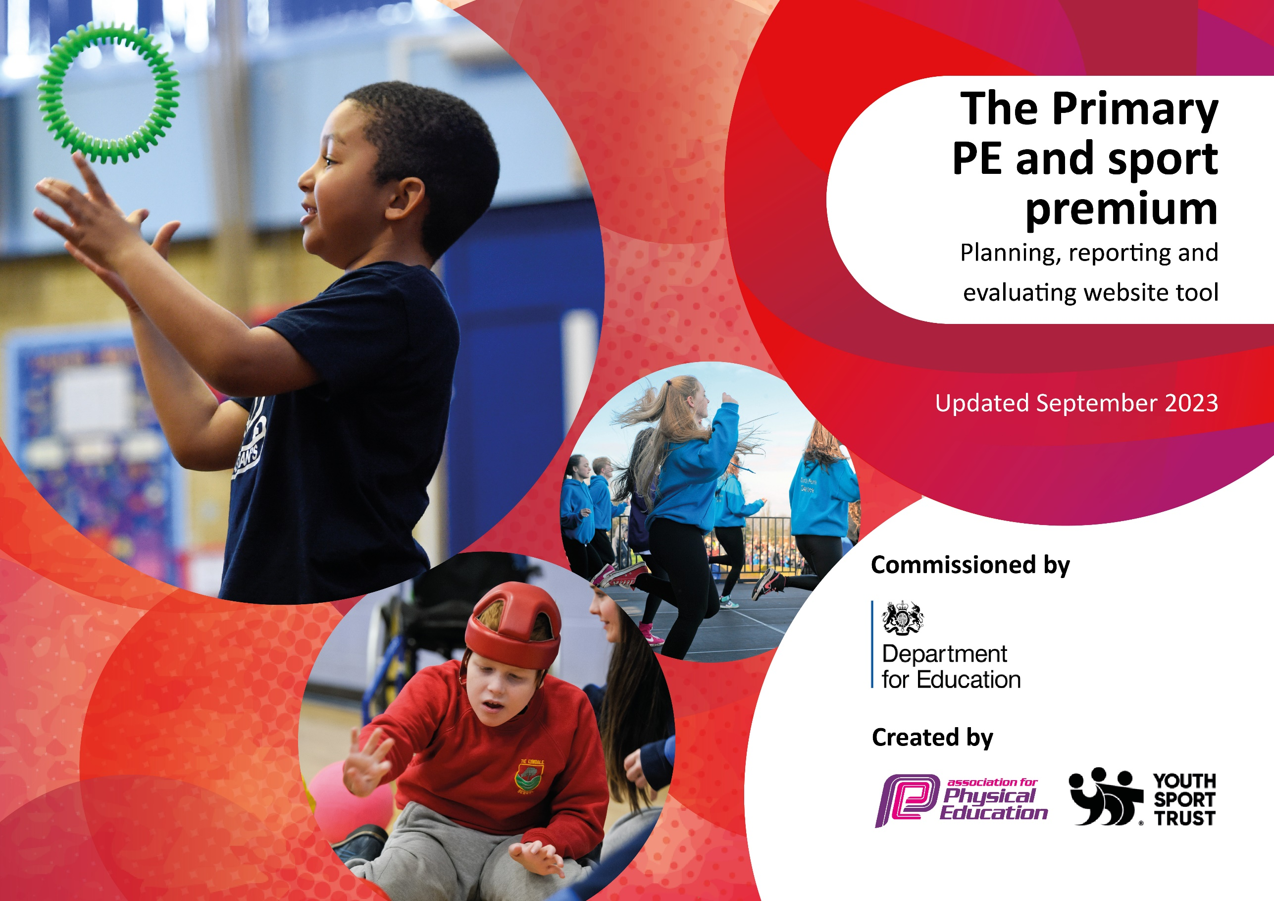

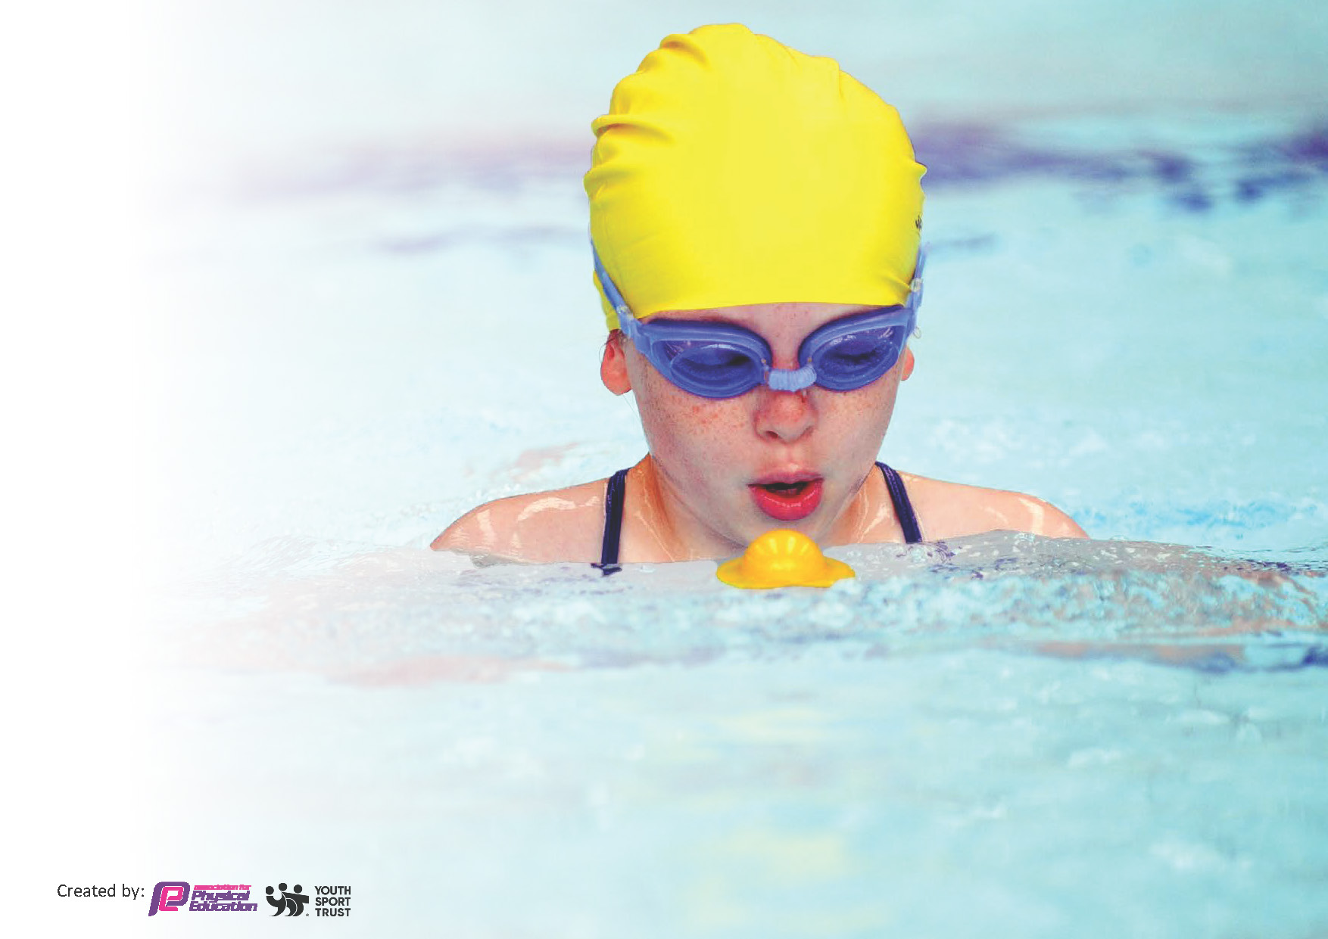
This template can be used for multiple purposes:
by:
- It enables schools to effectively plan their use of the Primary PE and sport premium
- It helps schools to meet the requirements (as set out in guidance) to publish information on their Primary PE and sport premium
- It will be an effective document to support Ofsted inspections enabling schools to evidence progress in Physical Education (PE) and evidence swimming attainment, which forms part of the PE National Curriculum. We would recommend schools consider
the Intent, Implementation and Impact of any spend, as examined within the Education Inspection Framework.

It is important that your grant is used effectively and based on school need.

Schools must use the funding to make additional and sustainable
improvements to the quality of the PE, School Sport and Physical Activity (PESSPA)
they offer. This means that you should use the Primary PE and sport premium to:

- Build capacity and capability within the school to ensure that improvements made now will benefit pupils joining the school in future years
- Develop or add to the PESSPA activities that your school already offers.

The Primary PE and sport premium should not be used to fund capital spend projects; the school’s core budget should fund these. Further detail on capital expenditure can be found in the updated Primary PE and sport premium guidance.

The Primary PE and sport premium guidance, outlines 5 key priorities that funding should be used towards. It is not

necessary that spending has to meet all the key priorities, you should select the priorities that you aim to use any funding towards.

Although completing this template is not a requirement for schools, schools are required to publish details of how they spend this funding. Schools must also outline what the impact this funding has had on pupils’ PE and sport participation and attainment and how any spending will be sustainable in the future. All funding must be spent by 31st July 2025.

The Department for Education has worked closely with the Association for Physical Education (afPE) and the Youth Sport Trust (YST) to develop this template and encourages schools to use it. This template is an effective way of meeting the reporting requirements of the Primary PE and sport premium.
Review of last year’s spend and key achievements (2023/2024)

We recommend you start by reflecting on the impact of current provision and reviewing your previous spend.

Activity/Action | Impact | Comments
- Provide a range of PE equipment that is safe and appropriate for all children throughout school.  - REAL Leaders - Arrange for children to be trained as Junior Sports Leaders who will lead sporting activities during lunch times, playtimes and after school, thus improving leadership skills  - REAL Dance - gives EVERY teacher, regardless of experience, the support and confidence to inspire and develop EVERY child through dance.  - Continue to offer a wider range of activities both within and outside the curriculum in order to get more pupils involved in a range of physical activities. | - New PE resources, particularly the gym equipment, enhanced the teaching of the curriculum.  - Real Leaders - Initial success with children organising games at playtimes, particularly with KS1.  - Real Dance- All staff received training/observed lesson. Staff thought the lessons resources were easy to use and lesson structure was easy to follow.  - The children participate well in Yoga activities that are inclusive, differentiated and age/stage-appropriate  - The coach has provide a wide variety of after school clubs throughout the year that have been well attended.  - Throughout the year, in small groups, Y5 children have been to the forest school in Bestwood Park. All the children have been enthusiastic while taking part in the outdoor activities and look forward to their turn. There has been a bonus half term where a targeted group of children eagerly attended from different year groups. | - Source and purchase new equipment to enable children to practice and take part in indoor athletics competitions.  - To raise and sustain interest in the Sports Leader Program for the whole year. Children to assist in the running of intra school competitions. Baseline leaders’ confidence and targeted children.  - Source a wider variety of coaches for after school clubs.  - Source alternatives for wall climbing.

Key priorities and Planning
This planning template will allow schools to accurately plan their spending.

Action – what are you planning to do | Who does this action impact? | Key indicator to meet | Impacts and how sustainability will be achieved? | Cost linked to the action
Provide a range of playground equipment to encourage active play.  Provide training for pupils/staff to run activities  Provide a range of PE equipment that is safe and appropriate for all children throughout school, including equipment to support the children in the indoor athletics competition | Lunchtime supervisors / teaching staff, coaches - as they need to lead the activity  pupils – as they will take part and lead some activities  teaching staff, coaches - as they need to lead the activity  pupils – as they will take part | Key indicator 1: The engagement of all pupils in regular physical activity – Chief Medical Officer guidelines recommend that primary school children undertake at least 30 minutes of physical activity a day in school | More pupils encouraged to take part in PE and Sport Activities.  Pupils using the equipment and improving their core skills  Pupils performing well in Indoor Athletics competitions | £500 costs for additional coaches to support lunchtime sessions.  £500 for equipment  £500 for storage  £3000 for the equipment
REAL Leaders - Arrange for children to be trained as Junior Sports Leaders who will lead sporting activities during lunch times, playtimes and after school, thus improving leadership skills | Lunchtime supervisors - as they need to support the leaders in the activities  pupils – as they will take part and lead some activities | Key indicator 2: The profile of PE and sport being raised across the school as a tool for whole school improvement | More pupils encouraged to take part in PE and Sport Activities during playtime.

REAL Foundations CPD for the reception staff  CPD for Real PE for all staff | All teaching staff. | Key indicator 3: Increased confidence, knowledge and skills of all staff in teaching PE and sport | Primary teachers more confident to deliver effective PE. | £1950 for all staff to undertake CPD.
Continue to offer a wider range of activities both within and outside the curriculum in order to get more pupils involved in a range of physical activities.  - Yoga Coach ensures children are inspired to participate in Yoga activities that are inclusive, differentiated and age/stage-appropriate  - Provide an opportunity for each child to attend a wall-climbing session.  - Provide a wide variety of after school clubs that support all the children throughout the year  - Enable children to go to forest school where they learn in the outdoors  - Extra swimming lessons for Y6 children not achieving 25m.  - Bikeability – safe cycling sessions | All pupils | Key indicator 4: Broader experience of a range of sports and activities offered to all pupils | Supporting pupils to undertake extra activities inside and outside of school, including teaching water safety and swimming and as a result improved 50% of pupil’s attainment in PE | Yoga coach - £1295  Wall climbing £1000  Sports clubs - £2000  Forest School - £5000  Extra swim - £100  Bikeability - £450
Hold intra school competitions during lunch time.  Enter at last 5 competitions/ events organised by LEAD and SOLAR | All pupils  Most pupils | Key indicator 5: Increased participation in competitive sport | At least 60% of children to have the opportunity to take part in inter school competitions. | Entry fees/transport - £500

Key achievements 2024-2025
This template will be completed at the end of the academic year and will showcase the key achievements schools have made with their Primary PE and sport premium spending.

Activity/Action | Impact | Comments

Swimming Data
Meeting National Curriculum requirements for swimming and water safety.
Priority should always be given to ensuring that pupils can perform safe self-rescue even if they do not fully meet the first two requirements of the National Curriculum programme of study

Question | Stats: | Further context  Relative to local challenges
What percentage of your current Year 6 cohort can swim competently, confidently and proficiently over a distance of at least 25 metres? | % | Use this text box to give further context behind the percentage.  e.g., 30% - we are struggling to get pool space due to our local pool closing so we have had to use a much smaller local school pool. We have had to limit the number of pupils attending swimming lessons during one term which means some pupils have attended fewer swimming lessons than others.
What percentage of your current Year 6 cohort can use a range of strokes effectively [for example, front crawl, backstroke, and breaststroke]? | % | Use this text box to give further context behind the percentage.  e.g., Even though your pupils may swim in another year please report on their attainment on leaving primary school at the end of the summer term 2024

What percentage of your current Year 6 cohort are able to perform safe self-rescue in different water-based situations? | % | Use this text box to give further context behind the percentage.
If your schools swimming data is below national expectation, you can choose to use the Primary PE and sport premium to provide additional top-up sessions for those pupils that did not meet National Curriculum  requirements after the completion of core lessons. Have you done this? | Yes/No
Have you provided CPD to improve the knowledge and confidence of staff to be able to teach swimming and water safety? | Yes/No

Signed off by:

Head Teacher: | (Name)
Subject Leader or the individual responsible for the Primary PE and sport premium: | (Name and Job Title)
Governor: | (Name and Role)
Date:

