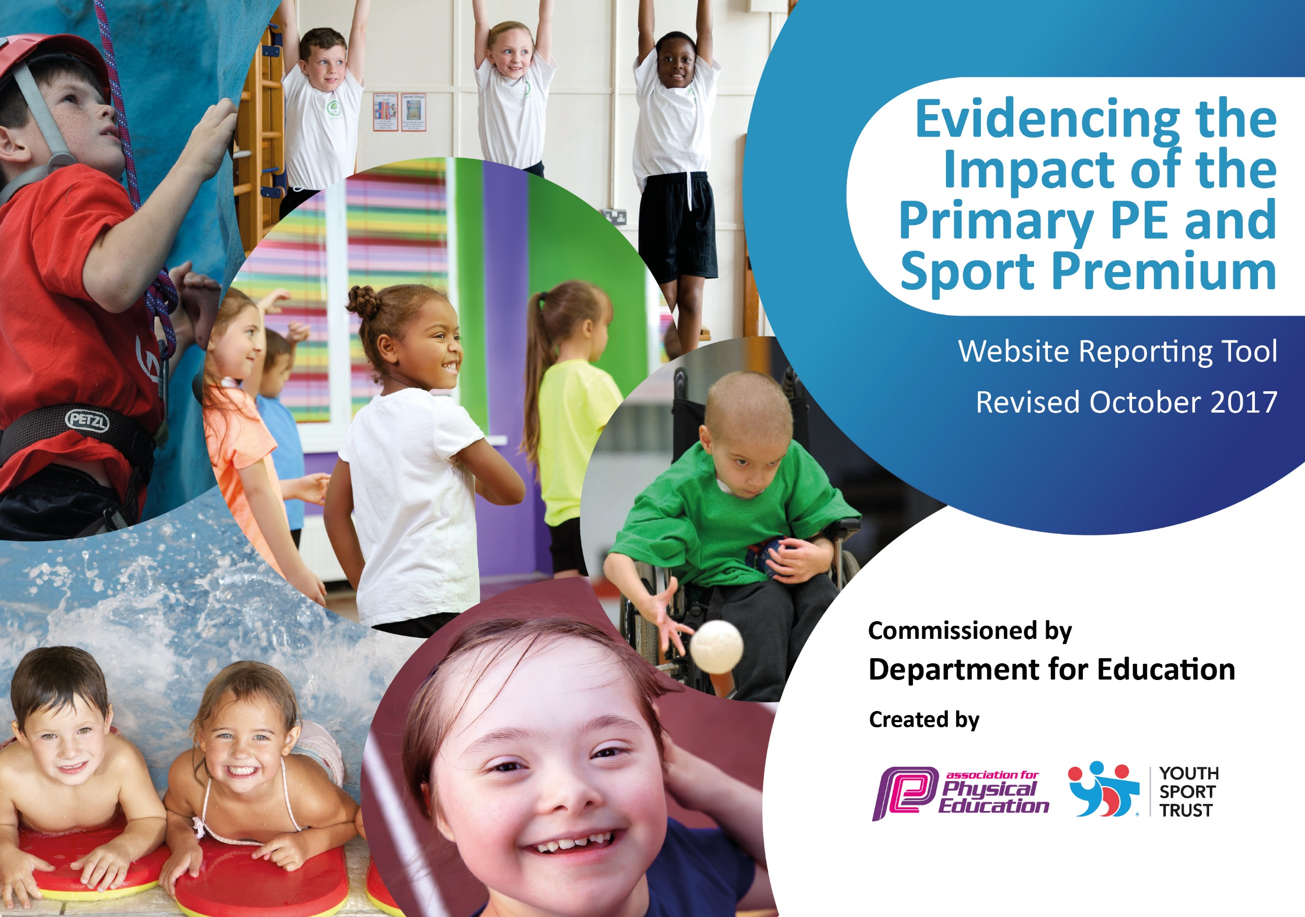

Schools must use the funding to make **additional and sustainable** improvements to the quality of PE and sport they offer. This means that you should use the Primary PE and Sport Premium to:

* develop or add to the PE and sport activities that your school already offers
* 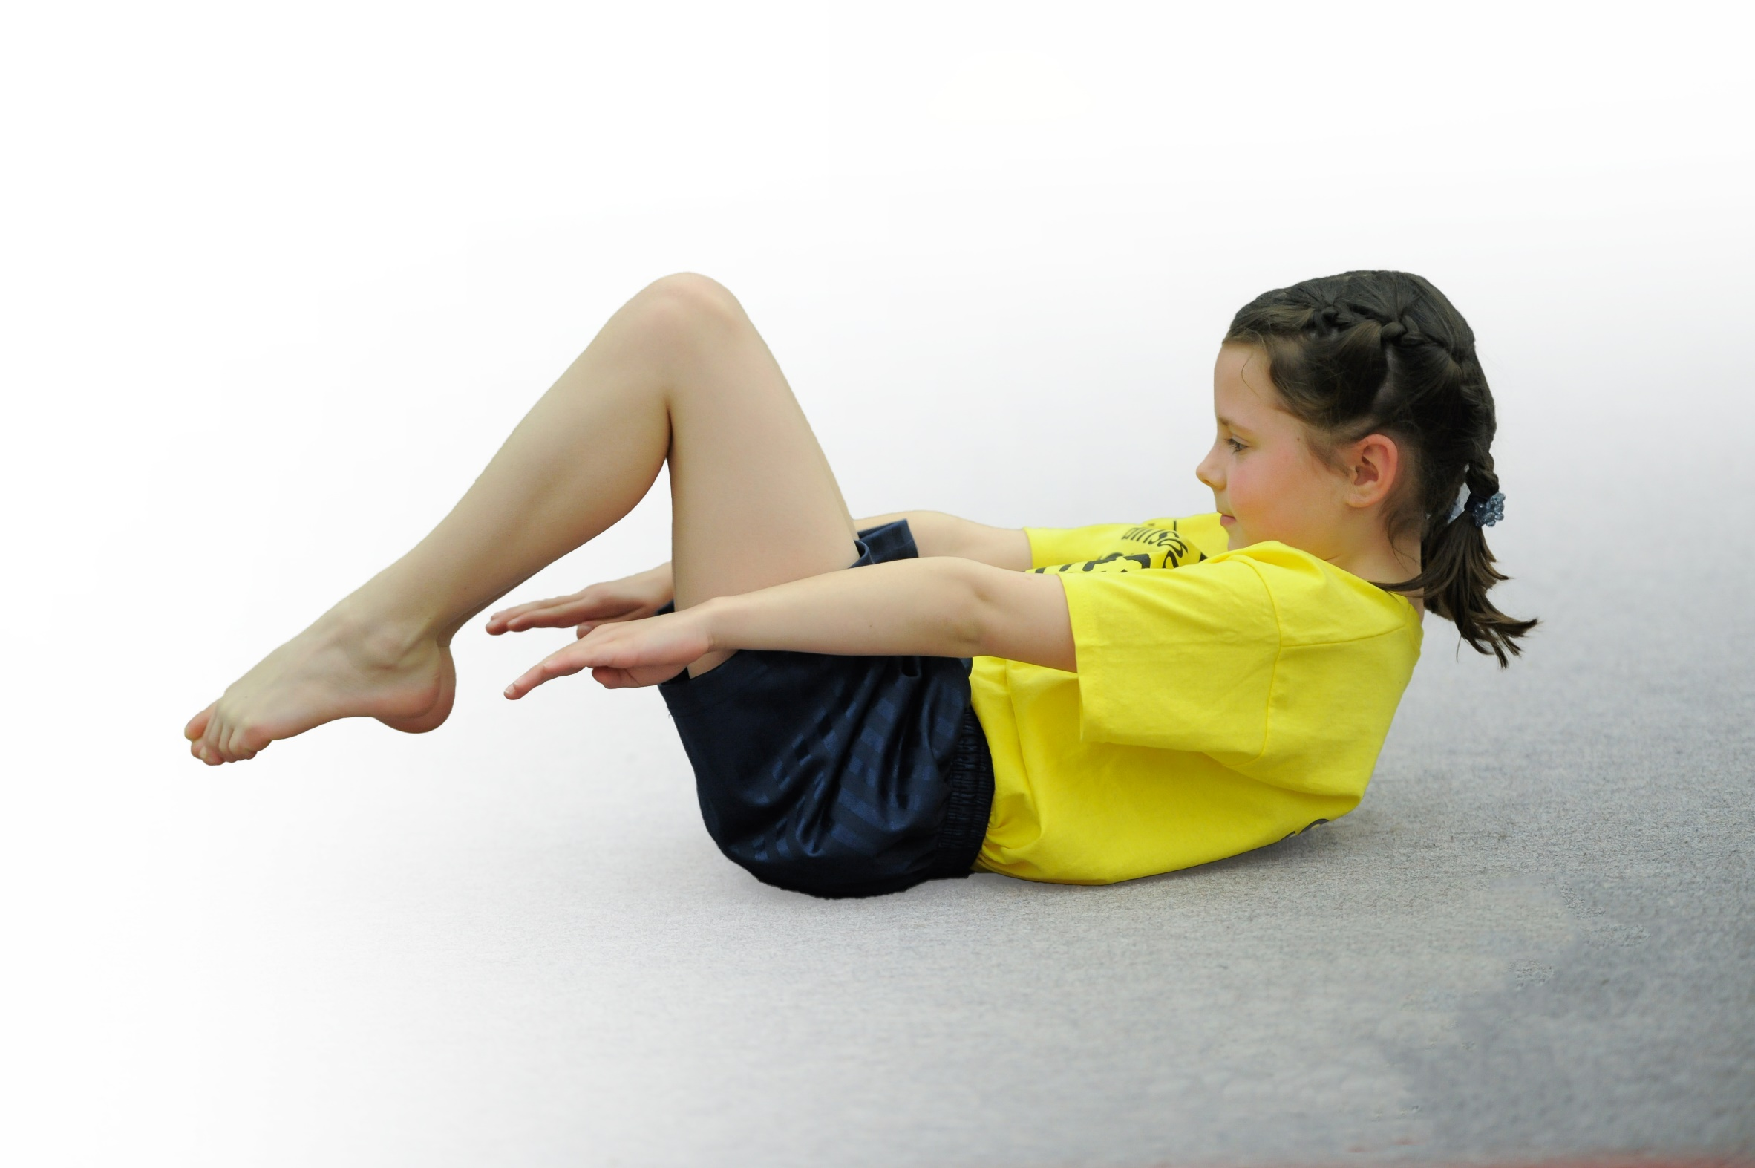build capacity and capability within the school to ensure that improvements made now will benefit pupils joining the school in future years

Please visit [gov.uk](https://www.gov.uk/guidance/pe-and-sport-premium-for-primary-schools) for the revised DfE guidance including the 5 key indicators across which schools should demonstrate an improvement. This document will help you to review your provision and to report your spend. DfE encourages schools to use this template as an effective way of meeting the reporting requirements of the Primary PE and Sport Premium.

We recommend you start by reflecting on the impact of current provision and reviewing the previous spend.

Under the [Ofsted Schools Inspection Framework](https://www.gov.uk/government/publications/school-inspection-handbook-from-september-2015), inspectors will assess how effectively leaders use

the Primary PE and Sport Premium and measure its impact on outcomes for pupils, and how effectively [governors](https://www.gov.uk/government/publications/governance-handbook) hold them to account

for this.

Schools are required to [publish details](https://www.gov.uk/guidance/what-maintained-schools-must-publish-online#pe-and-sport-premium-for-primary-schools) of how they spend this funding as well as on the impact it has on pupils’ PE

and sport participation and attainment.

We recommend regularly updating the table and

publishing it on your website as evidence

of your ongoing review into how you are using the money

to secure maximum, sustainable impact. To see an example of how to complete the table please click [HERE](http://www.afpe.org.uk/physical-education/wp-content/uploads/Template-Exemplification.pdf).

Support for review and reflection - considering the 5 key indicators from DfE, what development needs are a priority for your setting and your students now and why? Use the space below to reflect on previous spend, identify current need and priorities for the future.

|  |  |
| --- | --- |
| Key achievements to date: | Areas for further improvement and baseline evidence of need: |
| * New PE resources, particularly the gym equipment, enhanced the teaching of the curriculum. * Initial success with children organising games at playtimes, particularly with KS1. * The children participate well in Yoga activities that are inclusive, differentiated and age/stage-appropriate * The coach has provide a wide variety of after school clubs throughout the year that have been well attended. * Throughout the year, in small groups, Y5 children have been to the forest school in Bestwood Park. All the children have been enthusiastic while taking part in the outdoor activities and look forward to their turn. There has been a bonus half term where a targeted group of children eagerly attended from different year groups. | * Source and purchase new equipment to enable children to practice and take part in indoor athletics competitions. * To raise and sustain interest in the Sports Leader Program for the whole year. Children to assist in the running of intra school competitions. Baseline leaders’ confidence and targeted children. * Source a wider variety of coaches for after school clubs. * Source alternatives for wall climbing. |

**Action Plan and Budget Tracking**

Capture your intended annual spend against the 5 key indicators. Clarify the success criteria and evidence of impact that you intend to measure to evaluate for students today and for the future.

|  |  |  |  |  |
| --- | --- | --- | --- | --- |
| **Academic Year:** 2023/24 | **Total fund allocated:** £17800 | **Date Updated:30/8/23** | |  |
| **Key indicator 1:** The engagement of all pupils in regular physical activity – Chief Medical Officer guidelines recommend that primary school children undertake at least 30 minutes of physical activity a day in school | | | | Percentage of total allocation: |
| 20% |
| School focus with clarity on intended **impact on pupils**: | Actions to achieve: | Funding allocated: | Evidence and impact: | Sustainability and suggested next steps: |
| Re-develop the KS2 playground (permanent play equipment) to encourage more active play during playtimes to increase their levels of fitness.  Provide a range of playground equipment to encourage active play.  Provide a range of PE equipment that is safe and appropriate for all children throughout school.  Arrange CPD for the Family Funs aspect of REAL PE to encourage families to be more active at home. | * Redesign playground in respect to extension work. * Organise work installation date * Brief pupils/staff on how to use/supervise equipment * Write risk assessment * Audit current playground equipment. * Consult with children about what equipment they would like. * Source and purchase equipment and a storage unit * Monitor the use of the equipment   • Audit resources and purchase the required equipment.  • Ensure PE resources are available, appropriate and fit for purpose   * Arrange with REAL PE training and resources for Family Funs * Evaluate impact on the levels of physical activity at home | £255  £3000  £500  Cost included in REAL PE Legacy | Due to building work, the development of the KS2 playground will be postponed to next year  Playground equipment was well used by children though, because of loss and breakages, PE equipment has been used. More permanent suitable storage remains a priority.  Following an audit, consumables such as footballs/tennis balls were purchased  This was postponed to next year as focus was on REAL Dance. Resources are in school. | Once the playground is developed, the equipment will be permanent and the only cost will be for ongoing maintenance.  Suitable storage is a priority as most damage/loss is due to there not being storage and systems in place to manage the equipment.  Replace renewables and make sure any equipment of new Dance Curriculum is sourced and purchased as well new equipment to train the children for sportshall athletics.  Organise and provide CPD for the lead staff on the initiative. |

|  |  |  |  |  |
| --- | --- | --- | --- | --- |
| **Key indicator 2:** The profile of PE and sport being raised across the school as a tool for whole school improvement | | | | Percentage of total allocation: |
| 31%  (shared with Key Indicator 3) |
| School focus with clarity on intended **impact on pupils**: | Actions to achieve: | Funding allocated: | Evidence and impact: | Sustainability and suggested next steps: |
| * REAL Leaders - Arrange for children to be trained as Junior Sports Leaders who will lead sporting activities during lunch times, playtimes and after school, thus improving leadership skills * REAL Play – An after school programme which supports families through the power of play. * REAL PE at Home - ideas and support to keep children and family active and healthy at home, all while having lots of fun!      * REAL Foundations | * Children and staff member attend training course. * Staff work with children to create timetable for activities during dinner time and playtimes, as well as organizing an after school club * Change activities regularly to avoid the dwindling enthusiasm * Increase the available resources to facilitate the activities * Provide CPD to run REAL Play. * Purchase any required resources * Pupils and families access and enjoy quality REAL Play sessions * Establish the interested families. * Provide CPD for parents to run REAL PE at Home * Purchase any required resources and distribute to interested families * Pupils and families access and enjoy quality REAL Play sessions      * Provide CPD for Reception staff. * Purchase any required resources * Staff deliver the REAL Foundation sessions * Monitor lessons to ensure effective delivery of the curriculum. | Cost included in REAL PE Legacy  Cost included in REAL PE Legacy  Cost included in REAL PE Legacy  Cost included in REAL PE Legacy | Due to the late timing of the staff member training, the children will be trained in the Autumn term.  Resources have been sourced and purchased. The introduction of the program will be postponed to next year as focus was on REAL Dance.  Resources have been sourced and purchased. The introduction of the program will be postponed to next year as focus was on REAL Dance.  Resources have been sourced and purchased. Staff training has started but will be completed next year. | All programmes to be in place next year. |

|  |  |  |  |  |
| --- | --- | --- | --- | --- |
| **Key indicator 3:** Increased confidence, knowledge and skills of all staff in teaching PE and sport | | | | Percentage of total allocation: |
| 28%  (shared with Key Indicator 2) |
| School focus with clarity on intended  **impact on pupils**: | * Actions to achieve: | Funding  allocated: | Evidence and impact: | Sustainability and suggested  next steps: |
| * Pupils to participate in orienteering sessions to support their work in other curriculum areas. * Pupils’ will benefit from improving their map-work skills and being active.      * REAL Dance - gives EVERY teacher, regardless of experience, the support and confidence to inspire and develop EVERY child through dance. | * Monitor/evaluate impact of sessions on pupils’ levels of activity and their learning * Provide CPD to teach REAL Dance. * Purchase any required resources * Pupils access and enjoy quality REAL Dance sessions | N/A  £4995 | CPD was provided by the equipment supplier. Some staff then effectively used the website to plan activities that the children enjoyed.  Whole training was late in the year, with example lessons being delivered and the use of the resources demonstrated. Impact will be shown next year. | Staff need to integrate the orienteering resources into other curriculum areas, using the website as a planning resource.  Staff to deliver full program of Dance next year. |

|  |  |  |  |  |
| --- | --- | --- | --- | --- |
| **Key indicator 4:** Broader experience of a range of sports and activities offered to all pupils | | | | Percentage of total allocation: |
| 52% |
| School focus with clarity on intended  **impact on pupils:** | Actions to achieve: | Funding  allocated: | Evidence and impact: | Sustainability and suggested  next steps: |
| Additional achievements:  Continue to offer a wider range of activities both within and outside the curriculum in order to get more pupils involved in a range of physical activities. | * Yoga Coach ensures children are inspired to participate in Yoga activities that are inclusive, differentiated and age/stage-appropriate * Provide an opportunity for each child to attend a wall-climbing session, progressing from clip ‘n’ climb to indoor wall climbing. * Provide a wide variety of after school clubs that support all the children throughout the year * Enable children to go to forest school where they learn in the outdoors | £2730  Clip ‘n’ climb £180 per class for the venue (X4 =£720)  Transport to venue – £600 for 4 classes  Indoor climbing?  £600  £1000  £3700 | The Yoga sessions continue to be a popular part of the PE curriculum, focussing on posture, flexibility and core strength.  The cost of transport was prohibitive, NCT changed its position of offering free school transport during school hours.  After school clubs were provided by the sports coach and were well attended. They also ran in school house competitions at lunchtime which were enjoyed by all the children.  The Y5 class who attend the Forest School sessions thoroughly enjoyed the focus on outdoor learning, including PE and science activities. | The sustainability of the ongoing cost of the yoga teacher will be looked into, possibly coming from existing PE budget.  Look into other sources of climbing wall, possibly mobile climbing wall? Install walls in sports hall  Look at other possibilities for after school clubs.  Continue to finance the Forest School. |

|  |  |  |  |  |
| --- | --- | --- | --- | --- |
| **Key indicator 5:** Increased participation in competitive sport | | | | Percentage of total allocation: |
| 3% |
| School focus with clarity on intended  **impact on pupils**: | Actions to achieve: | Funding  allocated: | Evidence and impact: | Sustainability and suggested  next steps: |
| Enter at last 5 competitions/ events organised by LEAD and SOLAR | * Ensure coach/es provide after school clubs to support children entering competitions * Enter sporting events through LEAD and SOLAR. | Cost within the cost of coach above.  Entry Fees/ transport - £500 | School entered the sports Superstars initiative and the Sportshall Athletics competition. All participants enthusiastically took part and the school will certainly be entering again next ytear. | Look into finding solutions to transport and adults to support a wider variety of team sport competitions. |